
s

POST AND TELECOMMUNICATIONS INSTITUTE OF TECHNOLOGY
FACULTY OF INFORMATION TECHNOLOGY 1


Assignment
SUBJECT : Information systems analysis and design

Class : E22HTTT
Topic name : Garage management
Student : Trần Nhật Minh - B22DCVT350

Hanoi, 2025

Subject No. 26
Duration: 90 minutes

A garage management system enables management staff, sales staff, warehouse staff, and customers to use:
- Management staff: view the statistics categories: services, parts, customers and suppliers. Service information management, spare parts.
- Warehouse staff: import spare parts from suppliers, manage supplier information
- Sale staff: receive customers, receive service and spare parts requests from customers, assign technical staff according to customer service requirements, receive payment from customers.
- Customer: Search service information, book an appointment online

Considering two modules and answering questions
- Customer searches for service information: selects the menu to find service / spare parts information → enters the service / part name to search → the system displays a list of services / parts whose name contains the entered keyword → clicks on a service/part to view details → the system displays detailed information about the service/part.
- Warehouse staff imports parts: selects the menu to import parts → finds and selects suppliers by name (add new if not exist) → Repeats until the end of part list wanted to import: finds and selects spare parts by name (add new if not exist) → enters quantity, unit price → at the end of part list, confirms → prints import invoice and pays to supplier.

- Requirement
1. Build the glossary list
Name | Meaning | Category/Type
Management Staff | Personnel responsible for overseeing operations and viewing system statistics | Actor (Human)
Sales Staff | Personnel who interact with customers, handle service requests, and process payments | Actor (Human)
Warehouse Staff | Personnel responsible for importing parts from suppliers and managing inventory | Actor (Human)
Customer | End users who search for services, book appointments, and request services/parts | Actor (Human)
Technical Staff | Personnel assigned to perform actual service work based on customer requirements | Actor (Human)
Supplier | External entities that provide spare parts to the garage | Actor (External Entity)
Service Information | Data about services offered by the garage including descriptions, pricing, and availability | Data/Information
Spare Parts | Physical components and parts used for vehicle repairs and maintenance | Business Entity
Statistics Categories | Grouped data views showing metrics for services, parts, customers, and suppliers | System Module
Import Parts | Business process of acquiring spare parts from suppliers and adding them to inventory | Business Process
Service Request | Customer inquiry or demand for a specific automotive service | Business Process
Parts Request | Customer inquiry or demand for specific spare parts | Business Process
Online Appointment | Digital booking system allowing customers to schedule service visits | System Function
Search Function | System capability to find services/parts by name using keyword matching | System Function
Service Menu | User interface element providing navigation to service-related functions | System Component
Import Menu | User interface element providing access to parts importation functions | System Component
Keyword | Search term entered by users to find specific services or parts | Data/Information
Service Details | Comprehensive information about a specific service including specifications and pricing | Data/Information
Part Details | Comprehensive information about a specific spare part including specifications and pricing | Data/Information
Supplier Information | Data about suppliers including contact details, terms, and available parts | Data/Information
Customer Information | Data about customers including contact details, service history, and preferences | Data/Information
Quantity | Numerical amount of spare parts being imported or requested | Data/Information
Unit Price | Cost per individual item of a spare part or service | Data/Information
Part List | Collection of spare parts being processed in a single import transaction | Business Entity
Import Invoice | Document generated after parts import showing quantities, prices, and total cost | Document/Output
Payment Processing | System function for handling customer payments for services and parts | System Function
Staff Assignment | Process of allocating technical personnel to specific customer service requests | Business Process
Supplier Selection | Process of choosing and managing suppliers for parts procurement | Business Process
Service Management | Administrative function for maintaining and updating service information | System Module
Parts Management | Administrative function for maintaining and updating spare parts information | System Module
System Display | User interface showing search results, details, or other information to users | System Component

2. Project information
Objective
The Garage Management System aims to provide a comprehensive digital solution for automotive service centers that streamlines operations across multiple user roles. The primary objectives include:
- Operational Efficiency: Automate and digitize key garage operations including service management, inventory control, and customer interactions
- Multi-Role Support: Provide tailored interfaces and functionalities for management staff, sales staff, warehouse staff, and customers
- Data Management: Centralize information about services, spare parts, customers, suppliers, and transactions
- Customer Experience Enhancement: Enable customers to search services, view details, and book appointments online
- Business Intelligence: Provide management with statistical insights across services, parts, customers, and suppliers
- Inventory Control: Facilitate efficient spare parts procurement and inventory management
- Financial Management: Support payment processing and invoice generation for transparent financial operations
Scope
In Scope
- User Management: Support for four distinct user roles with role-based access control
- Service Information Management: Complete CRUD operations for automotive services
- Spare Parts Management: Inventory management including import, tracking, and information maintenance
- Customer Management: Customer data management and service history tracking
- Supplier Management: Supplier information and relationship management
- Search Functionality: Keyword-based search for services and spare parts
- Online Appointment Booking: Customer self-service appointment scheduling
- Staff Assignment: Automatic or manual assignment of technical staff to service requests
- Payment Processing: Customer payment handling and transaction recording
- Reporting and Statistics: Dashboard views for management with key performance indicators
- Import Processing: Complete workflow for spare parts procurement from suppliers
- Invoice Generation: Automated invoice creation for parts import and customer transactions
Out of Scope
- Advanced Analytics: Complex business intelligence and predictive analytics
- Mobile Application: Native mobile apps (web-responsive design included)
- Integration with External Systems: Third-party ERP, CRM, or accounting system integration
- Advanced Scheduling: Complex resource scheduling algorithms
- Multi-location Support: Management of multiple garage locations
- Advanced Security Features: Biometric authentication, advanced encryption
How the Modules Work
Module 1: Customer Service Information Search
Workflow Process:
- Menu Selection: Customer accesses the service/parts search menu from the main interface
- Search Input: Customer enters service or part name in the search field
- Keyword Processing: System performs keyword matching against service/parts database
- Results Display: System presents a filtered list of services/parts containing the entered keywords
- Detail Selection: Customer clicks on a specific service/part from the results list
- Detail Presentation: System displays comprehensive information including descriptions, pricing, availability, and specifications
Technical Implementation:
- Uses partial string matching algorithms for flexible search
- Implements pagination for large result sets
- Provides real-time search suggestions
- Maintains search history for improved user experience
Module 2: Warehouse Staff Parts Import
Workflow Process:
- Import Initiation: Warehouse staff selects the import parts menu
- Supplier Management: Staff searches for suppliers by name, with option to add new suppliers if not found
- Parts Selection Loop: For each part in the import list:
  - Search and select spare parts by name
  - Add new parts to system if not existing
  - Enter quantity and unit price information
- Validation: System validates all entered data for completeness and accuracy
- Confirmation: Staff reviews and confirms the complete import transaction
- Documentation: System generates import invoice and processes supplier payment
Technical Implementation:
- Implements transaction management for data consistency
- Provides bulk import capabilities for efficiency
- Includes validation rules for price and quantity constraints
- Generates audit trails for all import activities

Information About Objects
Core Business Objects
Customer Object
- Attributes: Customer ID, Name, Contact Information, Address, Service History, Preferences, Registration Date
- Behaviors: Search Services, Book Appointments, View Service History, Make Payments
- Business Rules: Unique customer identification, mandatory contact information
Service Object
- Attributes: Service ID, Service Name, Description, Category, Price, Duration, Requirements, Availability Status
- Behaviors: Display Details, Update Information, Calculate Pricing, Check Availability
- Business Rules: Service pricing validation, category classification requirements
Spare Part Object
- Attributes: Part ID, Part Name, Description, Category, Unit Price, Stock Quantity, Supplier Information, Specifications
- Behaviors: Update Stock, Calculate Total Value, Check Availability, Generate Reorder Alerts
- Business Rules: Minimum stock levels, price consistency validation
Supplier Object
- Attributes: Supplier ID, Company Name, Contact Person, Address, Phone, Email, Payment Terms, Active Status
- Behaviors: Provide Parts, Process Orders, Update Information, Manage Contracts
- Business Rules: Unique supplier identification, mandatory contact information

Staff Objects
Management Staff
- Attributes: Staff ID, Name, Role, Department, Access Permissions
- Behaviors: View Statistics, Generate Reports, Manage System Configuration
Sales Staff
- Attributes: Staff ID, Name, Customer Assignment, Performance Metrics
- Behaviors: Handle Customer Requests, Process Payments, Assign Technical Staff
Warehouse Staff
- Attributes: Staff ID, Name, Inventory Responsibilities, Supplier Relationships
- Behaviors: Import Parts, Manage Inventory, Update Supplier Information
Technical Staff
- Attributes: Staff ID, Name, Specializations, Availability Status, Current Assignments
- Behaviors: Perform Services, Update Service Status, Report Completion
Transaction Objects
Service Request
- Attributes: Request ID, Customer ID, Service ID, Technical Staff ID, Status, Date, Priority
- Behaviors: Track Progress, Update Status, Calculate Costs
Parts Import Transaction
- Attributes: Transaction ID, Supplier ID, Import Date, Total Value, Status, Staff ID
- Behaviors: Process Import, Generate Invoice, Update Inventory

Payment Transaction
- Attributes: Payment ID, Customer ID, Amount, Payment Method, Transaction Date, Status
- Behaviors: Process Payment, Generate Receipt, Update Account Status

Relationships Among Objects
Primary Relationships
Customer-Service Relationships
- Customer searches Service (Many-to-Many): Customers can search multiple services, services can be searched by multiple customers
- Customer books Service (Many-to-Many): Customers can book multiple services, services can be booked by multiple customers
- Customer requests Service (One-to-Many): One customer can have multiple service requests
Staff-Customer Relationships
- Sales Staff handles Customer (One-to-Many): One sales staff member handles multiple customers
- Technical Staff serves Customer (Many-to-Many): Technical staff can serve multiple customers, customers can be served by multiple technical staff
Supplier-Parts Relationships
- Supplier provides Spare Parts (One-to-Many): One supplier provides multiple spare parts
- Supplier participates in Import Transaction (One-to-Many): One supplier can have multiple import transactions
Staff-Inventory Relationships
- Warehouse Staff manages Spare Parts (One-to-Many): Warehouse staff manages multiple spare parts
- Warehouse Staff processes Import Transaction (One-to-Many): Warehouse staff processes multiple import transactions
Internal Staff Relationships
- Sales Staff assigns Technical Staff (Many-to-Many): Sales staff can assign multiple technical staff members, technical staff can be assigned by multiple sales staff
- Management Staff oversees all Staff (One-to-Many): Management staff supervises other staff members
Data Flow Relationships
Search and Information Flow
- Customer → Search Query → System → Service/Parts Database → Results → Customer
- Management Staff → Statistics Request → System → Aggregated Data → Management Dashboard
Transaction Flow
- Customer → Service Request → Sales Staff → Technical Staff Assignment → Service Completion → Payment
- Warehouse Staff → Supplier Selection → Parts Selection → Import Confirmation → Invoice Generation → Payment Processing
Information Management Flow
- Management Staff → Service Information → System Database → Customer Search Results
- Warehouse Staff → Supplier Information → System Database → Import Transaction Processing
Dependency Relationships
- Service Requests depend on Customer and Service objects
- Import Transactions depend on Supplier and Spare Parts objects
- Payment Transactions depend on Customer and Service/Parts objects
- Staff Assignments depend on Staff and Customer objects
- Statistics generation depends on all transactional data objects
These relationships ensure data integrity, support business processes, and enable the system to function as an integrated solution for garage management operations.

3. Draw Use case diagrams
- General use case diagram:
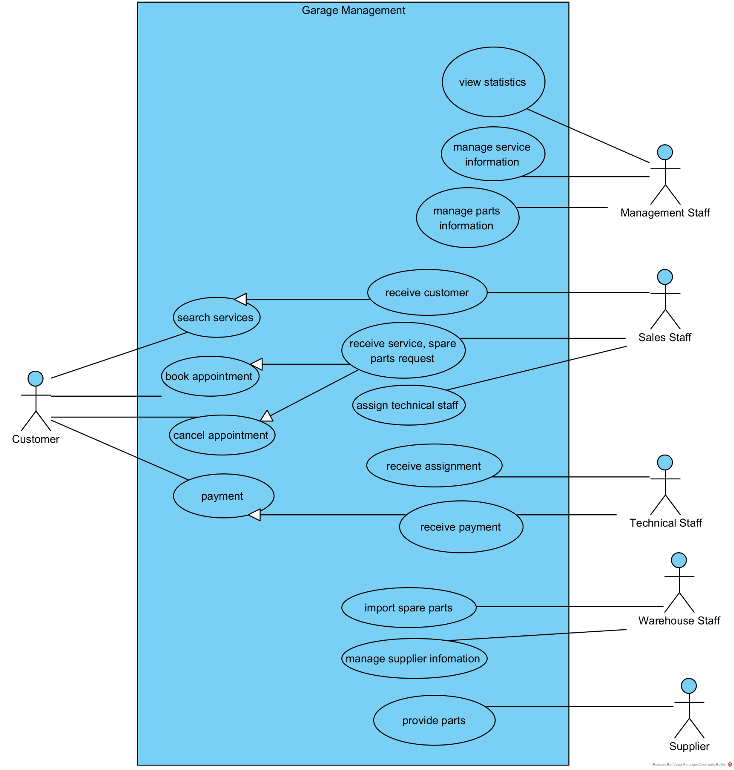
The use cases are described as follows:
- Book appointment: this use case enables the customer to schedule a service appointment online through the system.
- Cancel appointment: this use case enables the customer to cancel their existing service appointments.
- Search services: this use case enables the customer to search and view detailed information about available automotive services.
- Payment: this use case enables the customer to make payments for services and spare parts received.
- Receive service, spare parts request: this use case enables the sales staff to process and handle customer requests for automotive services and spare parts.
- Assign technical staff: this use case enables the sales staff to assign appropriate technical personnel to customer service requests.
- Receive customer: this use case enables the sales staff to welcome, register, and assist customers visiting the garage.
- Receive payment: this use case enables the sales staff to process customer payments for completed services and delivered parts.
- Receive assignment: this use case enables the technical staff to receive and acknowledge work assignments from sales staff.
- Import spare parts: this use case enables the warehouse staff to import spare parts from suppliers into the garage inventory.
- Manage supplier information: this use case enables the warehouse staff to maintain and update comprehensive information about parts suppliers.
- Manage parts information: this use case enables the management staff to maintain the master catalog of spare parts information and pricing.
- Manage service information: this use case enables the management staff to maintain the master catalog of automotive services offered by the garage.
- View statistics: this use case enables the management staff to access comprehensive business statistics and reports about services, parts, customers, and suppliers.
- Provide parts: this use case enables the supplier to deliver spare parts to fulfill the garage's inventory requirements.

- Customer searches for service information use case diagram:
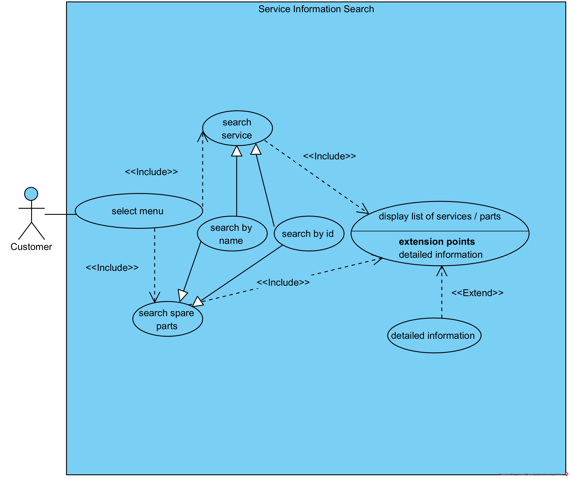
The use cases are described as follows:
- Select menu: this use case enables the customer to access the service and spare parts search interface from the main system menu.
- Search spare parts: this use case enables the customer to search for automotive spare parts available in the garage inventory.
- Search service: this use case enables the customer to search for automotive services offered by the garage.
- Search by name: this use case enables the customer to search for services or spare parts by entering the specific name or partial name.
- Search by id: this use case enables the customer to search for services or spare parts by entering the unique identification number or code.
- Display list of services / parts: this use case enables the system to show a comprehensive list of services or spare parts that match the customer's search criteria.
- Detailed information: this use case enables the customer to view comprehensive details about a specific service or spare part including specifications, pricing, availability, and descriptions.

- Warehouse staff imports parts use case diagram:
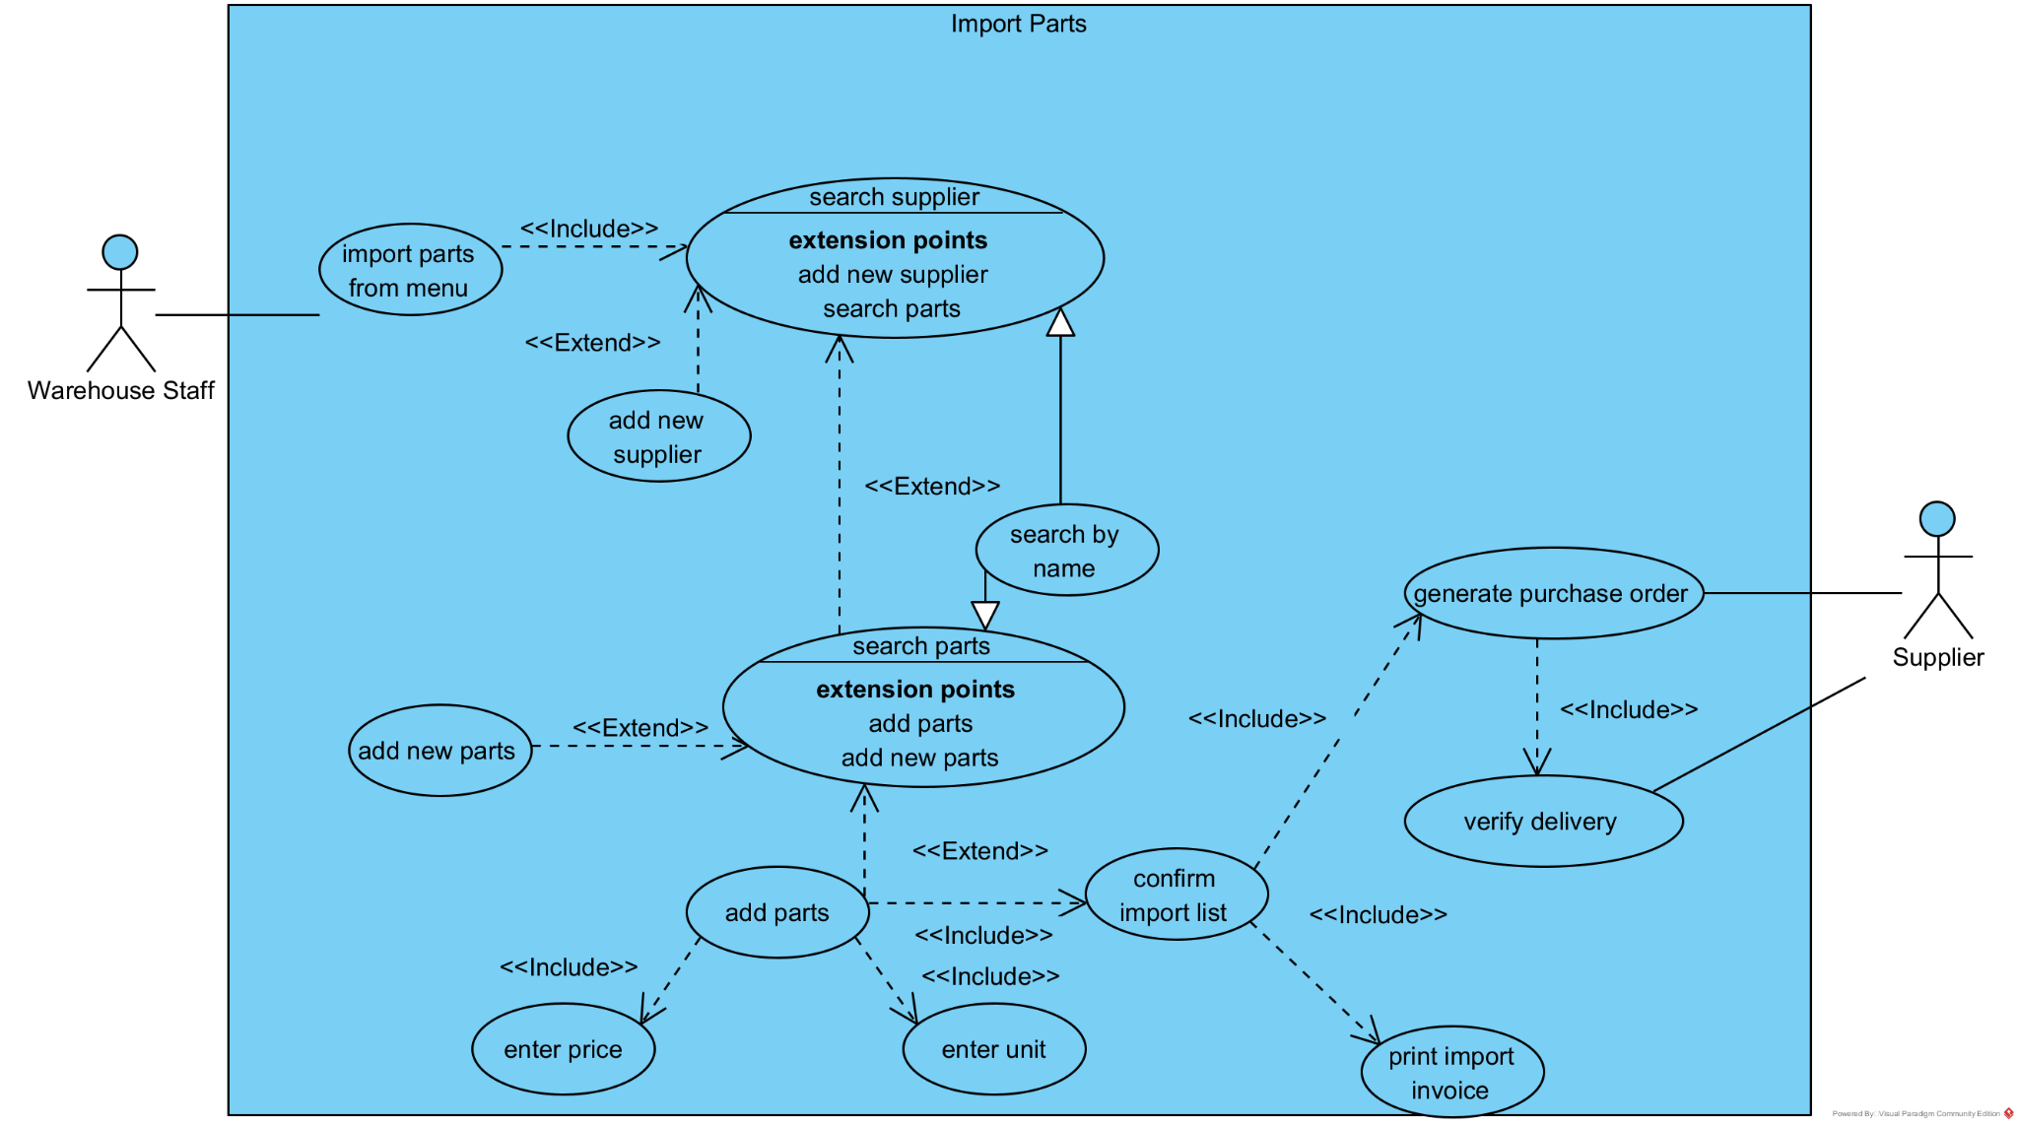
The use cases are described as follows:
- Import parts from menu: this use case enables the warehouse staff to access the parts importation functionality from the main system menu.
- Search supplier: this use case enables the warehouse staff to locate and select suppliers from the system database for parts procurement.
- Add new supplier: this use case enables the warehouse staff to create a new supplier record when the required supplier is not found in the existing database.
- Search parts: this use case enables the warehouse staff to locate spare parts in the system catalog for import purposes.
- Add new parts: this use case enables the warehouse staff to create new spare parts records when the required parts are not available in the existing catalog.
- Add parts: this use case enables the warehouse staff to add selected spare parts to the current import transaction list.
- Enter unit: this use case enables the warehouse staff to specify the quantity or number of units for each spare part being imported.
- Enter price: this use case enables the warehouse staff to input the unit cost or price for each spare part from the supplier.
- Search by name: this use case enables the warehouse staff to search for suppliers or spare parts using name-based search criteria.
- Confirm import list: this use case enables the warehouse staff to review and validate the complete list of parts, quantities, and prices before finalizing the import transaction.
- Generate purchase order: this use case enables the warehouse staff to create formal purchase order documents for suppliers based on the confirmed import list.
- Print import invoice: this use case enables the warehouse staff to generate and print invoice documentation for the parts import transaction.
- Verify delivery: this use case enables the warehouse staff and supplier to confirm that delivered parts match the purchase order specifications and quantities.

II.ANALYSIS
1. Standard and exceptional scenario
Scenario 1: Customer searches for service information

Use case | Service Information Search
Actors | Customer
Precondition | Customer logs into the garage management system
Post-condition | Customer views detailed information about desired automotive service
Main events | 1. Customer start the application to search for service information  2. The login interface appears with: an input text for username, an input text for password, a button to login.  3. The customer enters username as “minh29”, password as “minhlt” and then clicks on the login button.  4. The main customer UI appears with two options: Search service information and Search spare parts information.  5. The customer clicks on the “Search service information” button  6. System displays the service search interface with search box  7. Customer enters "oil change" in the search field and click on the search button  7. The system displays a list of services containing "oil change" keywords:  ID Name Price Duration  SV01 Quick Oil Change 50.000 VND 15 minutes  SV02 Standard Oil Change 100.000 VND 30 minutes  SV03 Premium Oil Change with Filter 200.000 VND 45 minutes  SV04 Full Service Oil Change 400.000 VND 60 minutes  8. Customer clicks on "Standard Oil Change" from the results list  9. System displays the detail of the chosen service:  Service Name Description Duration Price Vehicle Types Warranty Available Times  Standard Oil Change Professional oil drain and refill with quality motor oil 30 minutes 100.000 VND Most cars type 30 days or 3,000 miles Monday-Saturday 8AM-6PM  10.Customer reviews the detailed information  11. System displays "Book This Service" button for customer convenience
Exceptional | 1.1: Application fails to start  - Cause: Server is down or maintenance in progress  - System Response: Displays "Service temporarily unavailable. Please try again later."  - Resolution: Customer waits and retries, or calls garage directly  1.2: Network connection issues  - Cause: Customer has poor internet connectivity  - System Response: Shows "Connection timeout. Please check your internet connection."  - Resolution: Customer checks network connection and retries  1.3: Application crashes on startup  - Cause: Browser compatibility issues or JavaScript errors  - System Response: Browser displays error page  - Resolution: Customer tries different browser or clears cache  2.1: Login interface fails to load  - Cause: CSS or JavaScript files fail to load  - System Response: Interface appears broken or incomplete  - Resolution: Customer refreshes page or tries different browser  Exception E2.2: Input fields are unresponsive  - Cause: JavaScript errors or browser issues  - System Response: Cannot type in username/password fields  - Resolution: Customer refreshes page or uses keyboard navigation  3.1: Invalid username  - Trigger: Customer enters "minh30" instead of "minh29"  - System Response: "Invalid username or password. Please try again."  - Resolution: Customer re-enters correct username  3.2: Invalid password  - Trigger: Customer enters "minhltt" instead of "minhlt"  - System Response: "Invalid username or password. Please try again."  - Resolution: Customer re-enters correct password  3.3: Account locked  - Trigger: Customer has exceeded maximum login attempts  - System Response: "Account temporarily locked. Please try again in 15 minutes or contact support."  - Resolution: Customer waits or contacts customer service  3.4: Empty credentials  - Trigger: Customer clicks login with empty username or password  - System Response: "Please enter both username and password."  - Resolution: Customer fills in required fields  3.5: Login server timeout  - Cause: Authentication server is slow or overloaded  - System Response: "Login is taking longer than expected. Please wait..."  - Resolution: System retries automatically or customer tries again  4.1: UI fails to load completely  - Cause: Partial page load failure  - System Response: Some buttons or options are missing  - Resolution: Customer refreshes page or uses browser back/forward  4.2: User permissions error  - Trigger: Customer account has restricted access  - System Response: "Some features are not available for your account type."  - Resolution: Customer contacts support to upgrade account  5.1: Button unresponsive  - Cause: JavaScript error or page loading issues  - System Response: Nothing happens when button is clicked  - Resolution: Customer refreshes page or tries alternative navigation  5.2: Access denied  - Trigger: Customer account doesn't have search permissions  - System Response: "You don't have permission to access this feature."  - Resolution: Customer contacts support or tries guest access  6.1: Search interface fails to load  - Cause: Database connection issues  - System Response: "Search service temporarily unavailable."  - Resolution: Customer waits and retries, or browses service categories  6.2: Search box missing or broken  - Cause: CSS/JavaScript loading failure  - System Response: Interface appears but search functionality doesn't work  - Resolution: Customer uses alternative browser or contact methods  7.1: Empty search query  - Trigger: Customer clicks search button with empty search field  - System Response: "Please enter a search term."  - Resolution: Customer enters keywords and searches again  7.2: Invalid characters in search  - Trigger: Customer enters special characters "oil change!!@#"  - System Response: System filters invalid characters automatically  - Resolution: Search continues with valid characters only  7.3: Search takes too long  - Cause: Database is slow or overloaded  - System Response: "Searching... Please wait" with loading indicator  - Resolution: System eventually returns results or times out  7.4: Database error during search  - Cause: Database connection lost during search  - System Response: "Search failed. Please try again."  - Resolution: Customer retries search or contacts support  8.1: Service details fail to load  - Cause: Database error retrieving detailed information  - System Response: "Unable to load service details. Please try again."  - Resolution: Customer retries or selects different service  8.2: Service no longer available  - Trigger: Service was discontinued after search results were generated  - System Response: "This service is no longer available. Please choose another option."  - Resolution: Customer selects alternative service  8.3: Outdated information warning  - Cause: Service information hasn't been updated recently  - System Response: Shows details with "Information may not be current - last updated: [date]"  - Resolution: Customer calls for most current information  9.1: Incomplete service information  - Cause: Some detail fields are empty in database  - System Response: Shows available information with "Contact us for additional details"  - Resolution: Customer calls garage for complete information  9.2: Price format error  - Cause: Price stored incorrectly in database  - System Response: Shows "Price: Please contact for quote"  - Resolution: Customer calls for accurate pricing  9.3: Schedule information unavailable  - Cause: Available times not updated in system  - System Response: Shows "Schedule: Please call to check availability"  - Resolution: Customer contacts garage for scheduling  10.1: Information is confusing or unclear  - Trigger: Customer doesn't understand technical terms  - System Response: Provides "Need help?" link or chat support  - Resolution: Customer accesses help system or contacts support  10.2: Service doesn't match vehicle type  - Trigger: Customer realizes service isn't suitable for their vehicle  - System Response: Customer navigates back to search for alternatives  - Resolution: Customer searches for vehicle-specific services  11.1: Booking system unavailable  - Cause: Appointment booking module is down  - System Response: "Online booking temporarily unavailable. Please call to schedule."  - Resolution: Customer calls garage directly or tries later  11.2: Service fully booked  - Trigger: No available time slots for the service  - System Response: "This service is currently fully booked. Join waiting list?"  - Resolution: Customer joins waiting list or selects different time/service  11.3: Customer not eligible for online booking  - Trigger: New customer or special requirements needed  - System Response: "Please call to schedule this service for first-time customers."  - Resolution: Customer contacts garage for phone booking  11.4: Session timeout  - Cause: Customer took too long reviewing information  - System Response: "Your session has expired. Please log in again."  - Resolution: Customer logs in again and repeats process

Scenario 2: Warehouse staff imports parts

Use case | Imports Parts
Actors | Warehouse staff  Supplier
Precondition | Warehouse staff logs into the import parts system
Post-condition | Supplier ready shipping the order for Warehouse staff
Main events | 1. The staff logged into the import parts system, with username “  2. The staff notices a low stock for brake pads  3. The staff clicks on the import parts button  4. System displays the parts import interface  5. The staff clicks on "Find Supplier" and searches for "AutoParts Company"  6. System displays search results showing "AutoParts Company" supplier  7. The staff selects "AutoParts Plus" from the supplier list  8. The staff searches for brake and the system displays:  ID Name  PA01 Brake pads  PA02 Brake rotors  8. The staff clicks on "Brake pads" from the results list and enter quantity 20 and unit price 1.000.000 vnd  9.System displays import summary:  - 20 sets Premium Ceramic Brake Pads x 1m vnd = 20m  10.The staff reviews the complete import list and clicks "Confirm Import"  11. The system generates Import Invoice #INV-2025-1409  12. System prints invoice automatically  13. The staff processes payment to AutoParts Company via company credit account  14. System updates inventory:  - Brake Pads: Previous stock 5 → New stock 25  15. System sends purchase order confirmation to AutoParts Company  16. The staff receives confirmation message: "Import completed successfully"
Exceptional

2. Entity Classes Extraction
2.1. System
Step 1: Describe the system within a paragraph
The garage management system supports management staff, sales staff, warehouse staff, and customers to manage automotive services and spare parts. The system enables management staff to view statistics about services, parts, customers, and suppliers, and to manage service information and spare parts information. The system enables warehouse staff to import spare parts from suppliers and manage supplier information. The system enables sales staff to receive customers, handle service and spare parts requests from customers, assign technical staff according to customer service requirements, and receive payment from customers. The system enables customers to search service information and book appointments online. When a service is completed, an invoice is generated containing the services performed, parts used, and payment information.
Step 2+3: Extract nouns and classify them
Extracted Nouns:
- System: abstract noun → reject
- Information: common noun → reject
- Management staff: a kind of user → User (specialized as ManagementStaff)
- Sales staff: a kind of user → User (specialized as SalesStaff)
- Warehouse staff: a kind of user → User (specialized as WarehouseStaff)
- Customer: need to be managed → a class: Customer
- Technical staff: a kind of user → User (specialized as TechnicalStaff)
- Service: need to be managed → a class: Service
- Parts/Spare parts: need to be managed → a class: Part
- Supplier: need to be managed → a class: Supplier
- Statistics: service statistics → ServiceStat; parts statistics → PartStat; customer statistics → CustomerStat; supplier statistics → SupplierStat
- Request: service request, parts request → ServiceRequest
- Payment: need to be managed → a class: Payment
- Invoice: need to be managed → a class: Invoice
- Appointment: need to be managed → a class: Appointment
Initial Classes Obtained:
- Core entities: Customer, Service, Part, Supplier, User
- Transaction entities: ServiceRequest, Payment, Invoice, Appointment
- Statistical entities: ServiceStat, PartStat, CustomerStat, SupplierStat
Step 4+5: Quantity and object relationships among classes
User Hierarchy:
- User is an abstract class with specializations: ManagementStaff, SalesStaff, WarehouseStaff, TechnicalStaff
- Relationship: Generalization (inheritance)
Customer - Service Relationship:
- A Customer may search many Services, a Service may be searched by many Customers
- Customer - Service is n-n → Need intermediate class: ServiceSearch
Customer - Appointment Relationship:
- A Customer may book many Appointments, an Appointment belongs to one Customer
- Customer - Appointment is 1-n
Customer - ServiceRequest Relationship:
- A Customer may make many ServiceRequests, a ServiceRequest belongs to one Customer
- Customer - ServiceRequest is 1-n
ServiceRequest - Service Relationship:
- A ServiceRequest may include many Services, a Service may be used in many ServiceRequests
- ServiceRequest - Service is n-n → Need intermediate class: ServiceItem
ServiceRequest - Part Relationship:
- A ServiceRequest may use many Parts, a Part may be used in many ServiceRequests
- ServiceRequest - Part is n-n → Need intermediate class: PartUsage
ServiceRequest - TechnicalStaff Relationship:
- A ServiceRequest is assigned to one TechnicalStaff, a TechnicalStaff may handle many ServiceRequests
- ServiceRequest - TechnicalStaff is n-1
ServiceRequest - Invoice Relationship:
- A ServiceRequest generates one Invoice, an Invoice belongs to one ServiceRequest
- ServiceRequest - Invoice is 1-1 → Keep separate for business logic
Invoice - Payment Relationship:
- An Invoice receives one Payment, a Payment belongs to one Invoice
- Invoice - Payment is 1-1 → Keep separate for transaction tracking
Supplier - Part Relationship:
- A Supplier may supply many Parts, a Part may be supplied by many Suppliers (at different times)
- Supplier - Part is n-n → Need intermediate class: ImportTransaction
WarehouseStaff - ImportTransaction Relationship:
- A WarehouseStaff may create many ImportTransactions, an ImportTransaction is created by one WarehouseStaff
- WarehouseStaff - ImportTransaction is 1-n
ImportTransaction - Part Relationship:
- An ImportTransaction may include many Parts, a Part may be imported in many ImportTransactions
- ImportTransaction - Part is n-n → Need intermediate class: ImportItem
Statistical Classes Relationships:
- ServiceStat inherits from Service (reuses service attributes)
- PartStat inherits from Part (reuses part attributes)
- CustomerStat inherits from Customer (reuses customer attributes)
- SupplierStat inherits from Supplier (reuses supplier attributes)
- Relationship: Generalization (inheritance)
Final Entity Classes:
Primary Entities:
- Customer, Service, Part, Supplier
- User (with subclasses: ManagementStaff, SalesStaff, WarehouseStaff, TechnicalStaff)
Transaction Entities:
- ServiceRequest, Invoice, Payment, Appointment, ImportTransaction
Association Entities (n-n resolution):
- ServiceItem (ServiceRequest ↔ Service)
- PartUsage (ServiceRequest ↔ Part)
- ImportItem (ImportTransaction ↔ Part)
- ServiceSearch (Customer ↔ Service)
Statistical Entities:
- ServiceStat, PartStat, CustomerStat, SupplierStat
Entity Relationships Summary:
- Customer 1-n Appointment
- Customer 1-n ServiceRequest
- Customer n-n Service (via ServiceSearch)
- ServiceRequest n-n Service (via ServiceItem)
- ServiceRequest n-n Part (via PartUsage)
- ServiceRequest n-1 TechnicalStaff
- ServiceRequest 1-1 Invoice
- Invoice 1-1 Payment
- Supplier n-n Part (via ImportTransaction)
- ImportTransaction n-n Part (via ImportItem)
- WarehouseStaff 1-n ImportTransaction
- SalesStaff 1-n ServiceRequest
- SalesStaff 1-n Payment
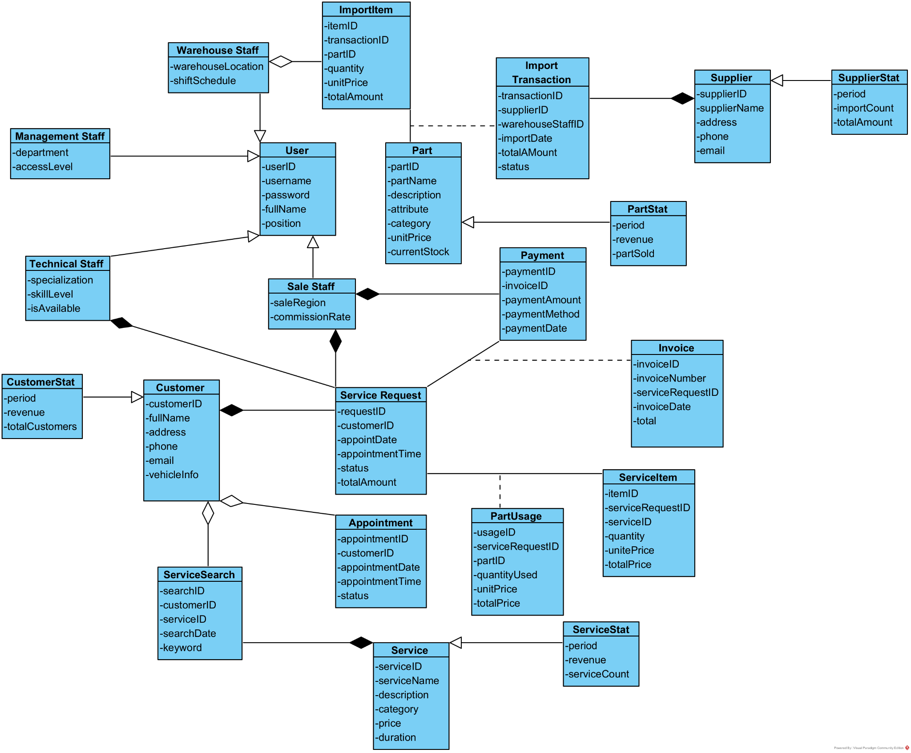
2.2. Customer searches for service information:
Entity class extraction
Noun extracting approach
Step 1: Describe the functions of the system in a short and complete paragraph.
The customer service information search module enables customers to search for automotive service and spare parts information through the garage management system. The system allows customers to select a search menu, enter service or part names as keywords, and displays a list of matching services or parts whose names contain the entered keywords. Customers can click on any service or part from the search results to view detailed information including descriptions, pricing, duration, and specifications. The system provides comprehensive information about each service and part to help customers make informed decisions about their automotive needs.
Step 2: Extract all nouns which appear in step 1. Each noun is counted only one time.
Extracted nouns:
- Customer
- Service
- Information
- Search
- Module
- Spare parts / Parts
- Names
- Keywords
- System
- Garage
- Management
- Menu
- List
- Results
- Descriptions
- Pricing
- Duration
- Specifications
- Decisions
- Needs
Step 3: Classify the nouns in step 2.
A noun could become an entity class:
- Customer: need to be managed → a class: Customer
- Service: need to be managed → a class: Service
- Parts: need to be managed → a class: Part
- Search: represents search activity → a class: SearchQuery
- Results: search results → a class: SearchResult
- Menu: interface element → a class: SearchMenu
A noun could become an attribute of an entity class:
- Names: attribute of Service and Part classes
- Keywords: attribute of SearchQuery class
- Descriptions: attribute of Service and Part classes
- Pricing: attribute of Service and Part classes
- Duration: attribute of Service class
- Specifications: attribute of Part class
Reject a noun if it is too general, too abstract, or out of the scope of the system:
- Information: too general → reject
- Module: system concept → reject
- System: abstract noun → reject
- Garage: physical location, out of scope → reject
- Management: too abstract → reject
- List: display concept → reject
- Decisions: customer action, out of scope → reject
- Needs: too abstract → reject
Initial Classes Obtained:
Customer, Service, Part, SearchQuery, SearchResult, SearchMenu
Step 4: Consider the quantitative relationship among entity classes.
Customer - SearchQuery relationship:
- A Customer may create many SearchQueries, a SearchQuery belongs to one Customer
- Customer - SearchQuery is 1-n → keep them
SearchQuery - SearchResult relationship:
- A SearchQuery generates one SearchResult, a SearchResult belongs to one SearchQuery
- SearchQuery - SearchResult is 1-1 → keep them or regroup into one class
- Decision: Keep separate for tracking search history and result caching
SearchResult - Service relationship:
- A SearchResult may contain many Services, a Service may appear in many SearchResults
- SearchResult - Service is n-n → should be divided into at least 2 relationships of type 1-n
- Create intermediate class: ServiceResultItem
SearchResult - Part relationship:
- A SearchResult may contain many Parts, a Part may appear in many SearchResults
- SearchResult - Part is n-n → should be divided into at least 2 relationships of type 1-n
- Create intermediate class: PartResultItem
Customer - Service relationship:
- A Customer may view many Services, a Service may be viewed by many Customers
- Customer - Service is n-n → should be divided into relationships of type 1-n
- This relationship is indirect through SearchQuery and SearchResult
Customer - Part relationship:
- A Customer may view many Parts, a Part may be viewed by many Customers
- Customer - Part is n-n → should be divided into relationships of type 1-n
- This relationship is indirect through SearchQuery and SearchResult
Step 5: Determine the object relationship among entity classes: generalization, aggregation, composition, association, dependence...
Relationships among classes are determined as follows:
Customer - SearchQuery relationship:
- A Customer may perform many SearchQueries. A SearchQuery is performed by one Customer.
- Customer - SearchQuery is 1-n association relationship.
SearchQuery - SearchResult relationship:
- A SearchQuery generates one SearchResult. A SearchResult is generated by one SearchQuery.
- SearchQuery - SearchResult is 1-1 composition relationship.
- SearchResult cannot exist without SearchQuery (strong ownership).
SearchResult - ServiceResultItem relationship:
- A SearchResult contains many ServiceResultItems. A ServiceResultItem belongs to one SearchResult.
- SearchResult - ServiceResultItem is 1-n composition relationship.
- ServiceResultItems cannot exist without their SearchResult.
SearchResult - PartResultItem relationship:
- A SearchResult contains many PartResultItems. A PartResultItem belongs to one SearchResult.
- SearchResult - PartResultItem is 1-n composition relationship.
- PartResultItems cannot exist without their SearchResult.
Service - ServiceResultItem relationship:
- A Service may appear in many ServiceResultItems (different search results). A ServiceResultItem references one Service.
- Service - ServiceResultItem is 1-n association relationship.
Part - PartResultItem relationship:
- A Part may appear in many PartResultItems (different search results). A PartResultItem references one Part.
- Part - PartResultItem is 1-n association relationship.
SearchMenu - SearchQuery relationship:
- A SearchMenu enables customers to create SearchQueries. This is a dependency relationship.
- SearchMenu depends on the search functionality but doesn't store data.
- SearchMenu → SearchQuery dependency relationship.
Generalization relationships:
- ServiceResultItem and PartResultItem both represent search result items.
- We could create an abstract class ResultItem with ServiceResultItem and PartResultItem as subclasses.
- ResultItem ← ServiceResultItem and PartResultItem (generalization/inheritance).
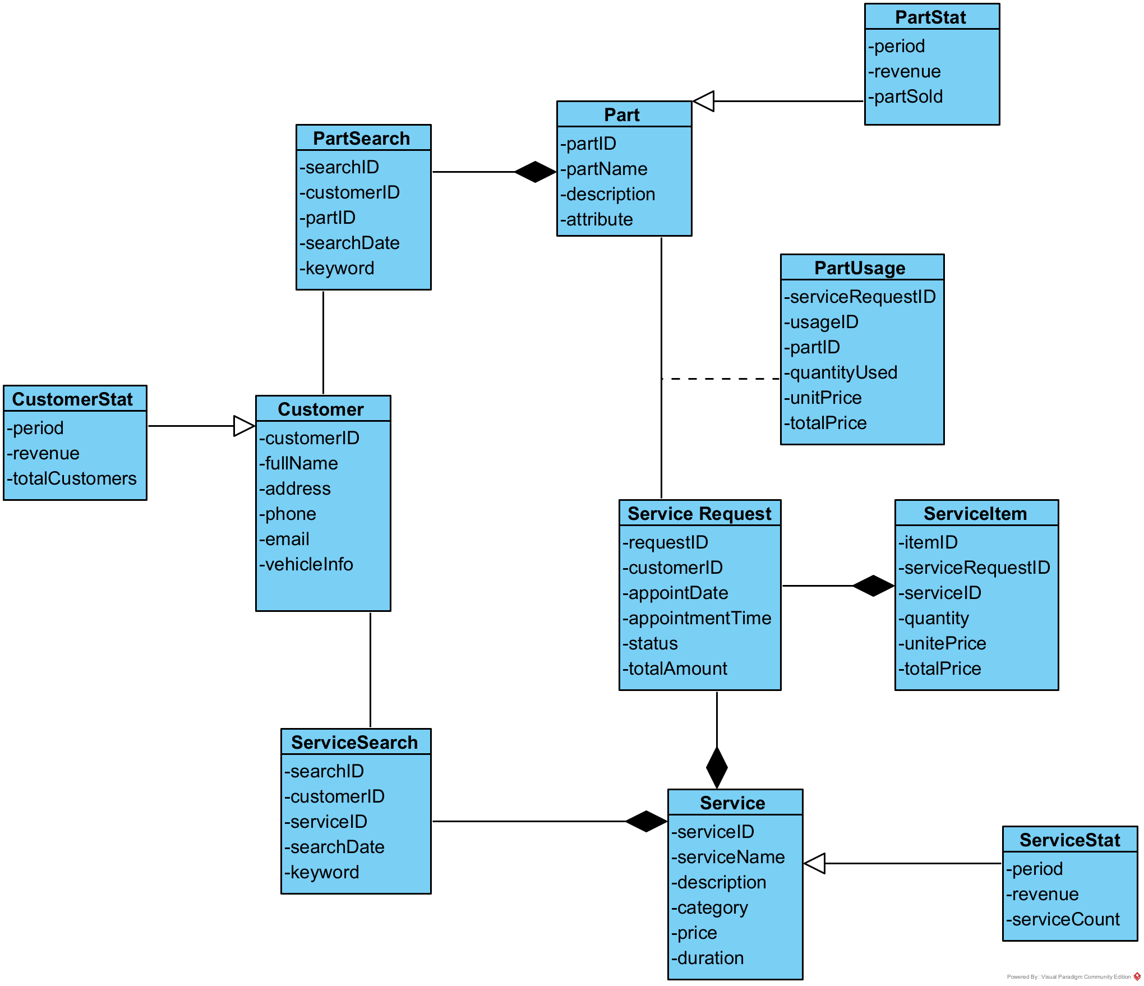

2.3. Warehouse Staff imports parts
Entity class extraction
Noun extracting approach
- Step 1: Describe the functions of the system in a short and complete paragraph.
- Step 2: Extract all nouns which appear in the step 1. Each noun is counted only one time.
- Step 3: Classify the nouns in the step 2.
  - A noun could become an entity class.
  - A noun could become an attribute of an entity class.
  - Reject a noun if it is too general, too abstract, or out of the scope of the system.
- Step 4: Consider the quantitative relationship among entity classes.
  - If it is 1-1 then: keep it or regroup two classes into one.
  - If it is 1-n then keep them.
  - If it is n-n, then it should be divided into at least 2 relationships of type 1-n.
- Step 5: Determine the object relationship among entity classes: generalization, aggregation, composition, association, dependence…
Applying Step 1: describe the system within a paragraph The warehouse staff parts import module enables warehouse staff to import spare parts from suppliers into the garage inventory system. The system allows warehouse staff to select the import parts menu, find and select suppliers by name with the option to add new suppliers if they don't exist in the system. For each import transaction, staff can repeatedly find and select spare parts by name, add new parts if they don't exist, enter quantity and unit price for each part until the complete parts list is assembled. At the end of the parts list, staff confirms the import transaction, and the system prints an import invoice and processes payment to the supplier while updating the inventory quantities automatically.
Step 2+3: extract nouns and classify them
- System: an abstract noun –> reject.
- Module: a system concept –> reject.
- Warehouse staff: need to be managed –> a class: WarehouseStaff
- Parts: need to be managed –> a class: Part
- Spare parts: same as Parts –> a class: Part
- Suppliers: need to be managed –> a class: Supplier
- Garage: physical location, out of the scope of the system –> reject
- Inventory: need to be managed –> a class: Inventory
- Menu: interface element, out of scope –> reject
- Names: attribute of Supplier and Part –> reject as class
- Option: interface concept –> reject
- Transaction: business process –> a class: ImportTransaction
- Import transaction: same as Transaction –> a class: ImportTransaction
- Quantity: attribute of import items –> reject as class
- Unit price: attribute of import items –> reject as class
- Price: same as unit price –> reject as class
- List: display concept –> reject
- Invoice: need to be managed –> a class: ImportInvoice
- Payment: need to be managed –> a class: SupplierPayment
- Quantities: attribute of Inventory –> reject as class
So we obtain the initial classes: WarehouseStaff, Part, Supplier, Inventory, ImportTransaction, ImportInvoice, SupplierPayment.
Step 4+5: quantity and object relationships among classes Relationships among classes are determined as follows:
- A WarehouseStaff may create many ImportTransactions, an ImportTransaction is created by one WarehouseStaff. So, WarehouseStaff – ImportTransaction is 1-n.
- A Supplier may be involved in many ImportTransactions, an ImportTransaction involves one Supplier: so Supplier – ImportTransaction is 1-n.
- An ImportTransaction may include many Parts, a Part may be included in many ImportTransactions at different times: so ImportTransaction – Part is n-n. So we could propose a class between them: ImportItem.
- An ImportTransaction generates one ImportInvoice. An ImportInvoice is generated by one ImportTransaction. So ImportTransaction – ImportInvoice is 1-1. We keep them separate for business process tracking.
- An ImportInvoice receives one SupplierPayment. A SupplierPayment settles one ImportInvoice. So ImportInvoice – SupplierPayment is 1-1. We keep them separate for financial audit.
- A Part has one Inventory record. An Inventory record tracks one Part. So Part – Inventory is 1-1. We keep them separate for inventory management operations.
- A Supplier receives many ImportInvoices for different transactions. So Supplier – ImportInvoice is 1-n.
- An ImportTransaction contains many ImportItems. An ImportItem belongs to one ImportTransaction. Moreover, in an ImportItem, we store specific information: quantity imported, unit cost, total cost. This association relationship determines these important attributes.
- A Part may appear in many ImportItems (different import transactions). An ImportItem references one Part. So Part – ImportItem is 1-n.
- In the case of relationships, ImportTransaction – ImportItem is composition (ImportItems cannot exist without ImportTransaction). ImportTransaction – ImportInvoice is composition (ImportInvoice cannot exist without ImportTransaction). ImportInvoice – SupplierPayment is composition (SupplierPayment cannot exist without ImportInvoice). Part – Inventory is composition (Inventory record is part of Part management).
- Other relationships (WarehouseStaff – ImportTransaction, Supplier – ImportTransaction, Supplier – ImportInvoice, Part – ImportItem) are association relationships as they represent business connections between independent entities.

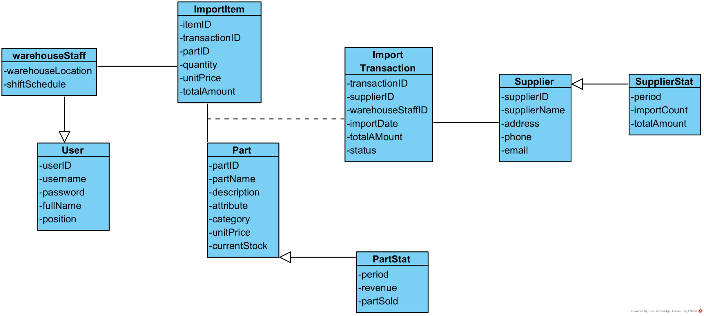
3. Class Diagram
3.1. Customer searches for services information
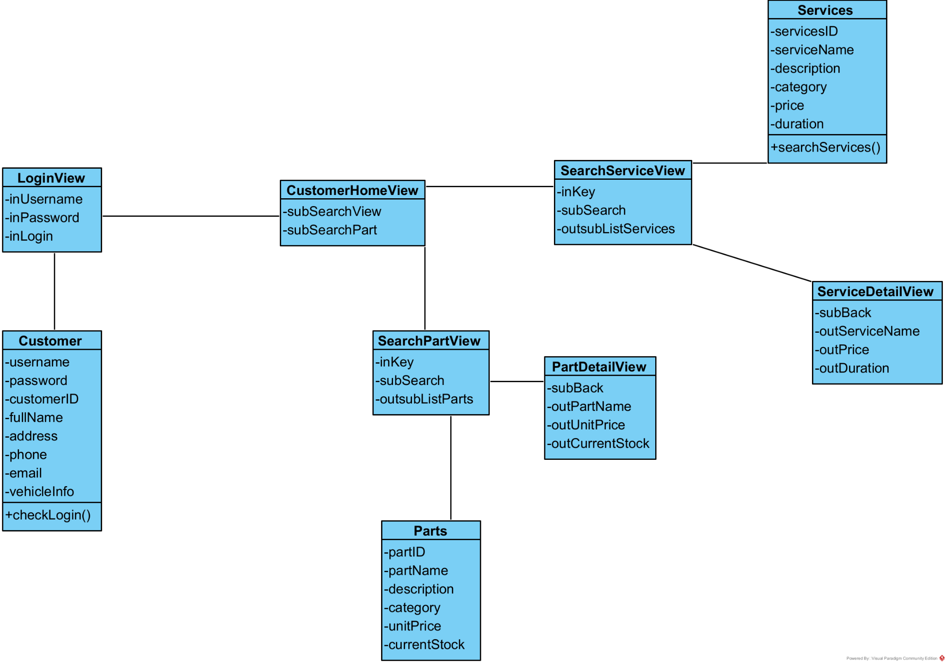
3.2 Warehouse Staff imports parts
Entity class extraction
Noun extracting approach
- Step 1: Describe the functions of the system in a short and complete paragraph.
- Step 2: Extract all nouns which appear in the step 1. Each noun is counted only one time.
- Step 3: Classify the nouns in the step 2.
  - A noun could become an entity class.
  - A noun could become an attribute of an entity class.
  - Reject a noun if it is too general, too abstract, or out of the scope of the system.
- Step 4: Consider the quantitative relationship among entity classes.
  - If it is 1-1 then: keep it or regroup two classes into one.
  - If it is 1-n then keep them.
  - If it is n-n, then it should be divided into at least 2 relationships of type 1-n.
- Step 5: Determine the object relationship among entity classes: generalization, aggregation, composition, association, dependence…
Applying Step 1: describe the system within a paragraph The warehouse staff parts import system enables warehouse staff to log into the system with username and password, then access the import home interface where they can search for suppliers and parts. The system allows warehouse staff to search for suppliers by keyword, view a list of suppliers, and add new suppliers with name, address, phone, and email information if they don't exist. Similarly, staff can search for parts by keyword, view a list of parts, and add new parts with name, quantity, and unit price details. After selecting suppliers and parts, the staff can view the import summary and confirm the import transaction to complete the parts importation process.
Step 2+3: extract nouns and classify them
- System: an abstract noun –> reject.
- Warehouse staff: a user of the system –> a class: WarehouseStaff
- Parts: items to be managed –> a class: Parts
- Import: business process, but represented by views –> reject as entity
- Username: attribute of WarehouseStaff –> reject as class
- Password: attribute of WarehouseStaff –> reject as class
- Interface: UI concept –> reject
- Home: UI concept –> reject
- Suppliers: business entities –> a class: Supplier
- Keyword: search parameter –> reject as class
- List: display concept –> reject
- Name: attribute of Supplier and Parts –> reject as class
- Address: attribute of Supplier –> reject as class
- Phone: attribute of Supplier –> reject as class
- Email: attribute of Supplier –> reject as class
- Quantity: attribute of import transaction –> reject as class
- Unit price: attribute of Parts –> reject as class
- Summary: display concept –> reject
- Transaction: business process, but not explicitly modeled –> could be added
- Process: abstract concept –> reject
- Login: system function –> represented by LoginView
- Search: system function –> represented by SearchSupplierView, SearchPartView
- View: UI components –> classes: LoginView, ImportHomeView, SearchSupplierView, AddSupplierView, SearchPartView, AddPartView, ConfirmView
So we obtain the classes from the diagram: WarehouseStaff, Supplier, Parts, LoginView, ImportHomeView, SearchSupplierView, AddSupplierView, SearchPartView, AddPartView, ConfirmView.
Step 4+5: quantity and object relationships among classes Relationships among classes in the diagram are determined as follows:
- A WarehouseStaff uses one LoginView for authentication. A LoginView authenticates one WarehouseStaff at a time. So WarehouseStaff – LoginView is 1-1 dependency.
- A LoginView leads to one ImportHomeView after successful login. So LoginView – ImportHomeView is 1-1 navigation dependency.
- An ImportHomeView provides access to SearchSupplierView and SearchPartView. So ImportHomeView – SearchSupplierView is 1-1 and ImportHomeView – SearchPartView is 1-1 navigation dependencies.
- A SearchSupplierView interacts with Supplier entity for search operations. So SearchSupplierView – Supplier is 1-n association (one view can display many suppliers).
- A SearchSupplierView can navigate to AddSupplierView when supplier not found. So SearchSupplierView – AddSupplierView is 1-1 navigation dependency.
- An AddSupplierView creates new Supplier entities. So AddSupplierView – Supplier is 1-1 creation dependency.
- A SearchPartView interacts with Parts entity for search operations. So SearchPartView – Parts is 1-n association (one view can display many parts).
- A SearchPartView can navigate to AddPartView when part not found. So SearchPartView – AddPartView is 1-1 navigation dependency.
- An AddPartView creates new Parts entities. So AddPartView – Parts is 1-1 creation dependency.
- An AddPartView leads to ConfirmView after part details are entered. So AddPartView – ConfirmView is 1-1 navigation dependency.
- A Supplier can provide many Parts over time, but this relationship is not explicitly shown in the current diagram. The diagram shows Supplier – Parts as a simple association, which could represent a general business relationship.
- In the case of UI relationships, all View classes have dependency relationships with each other representing navigation flow. These are not entity relationships but interface dependencies.
- The entity classes (WarehouseStaff, Supplier, Parts) have association relationships with their corresponding view classes, representing the MVC pattern where views interact with model entities.

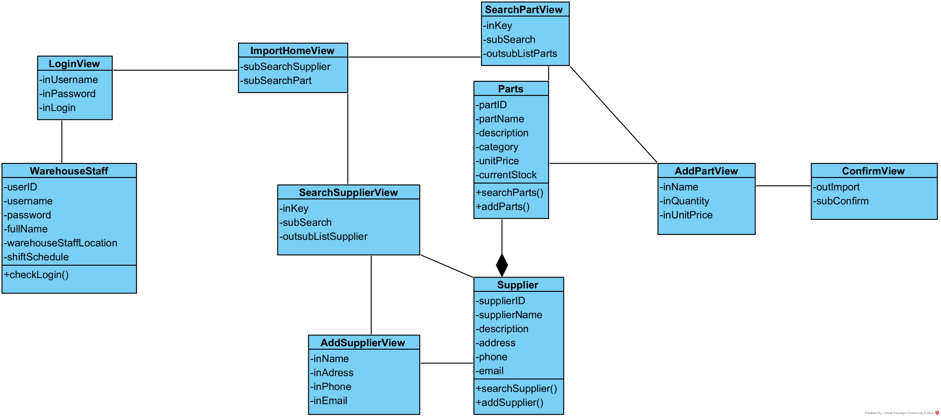

4.Activity analysis
4.1. Module customer searches services information
State diagram
• From the customer’s main interface, if the Search Service function is selected, the system navigates to the Search Services interface.
• In the Search Services interface, if the customer enters a services name and presses Search, the interface will display a list of services whose names contain the entered keyword.
• In the Search Services interface, if the customer selects a dish from the displayed list, the system navigates to the Service Detail interface.
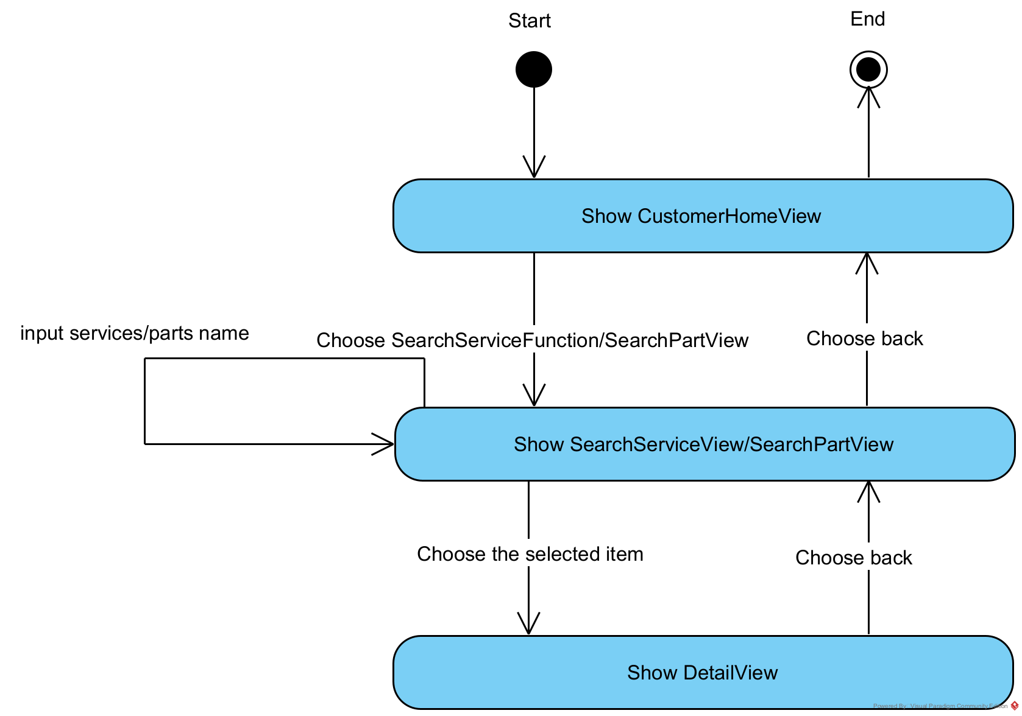
Scenario v.2:
1. In the customer’s main interface, after logging in, the customer selects the function Search Services Information.
2. Class CustomerHomeView calls SearchServiceView.
3. Class SearchServiceView is displayed to the customer.
4. The customer enters the name of the service to search.
5. Class SearchServiceView calls class Service to request service whose names contain the entered keyword.
6. Class Service searches for dishes that match the request.
7. Class Service returns the result to class SearchServiceView.
8. Class SearchServiceView displays the result to the customer.
9. The customer selects one service.
10. SearchServiceView calls class ViewDishDetail.
11. Class ViewDishDetail calls class Dish to request information about the selected dish.
12. Class Dish retrieves the dish information.
13. Class Dish returns the result to class ViewDishDetail.
14. Class ServiceDetailView displays the detailed information to the customer.

Communication diagram
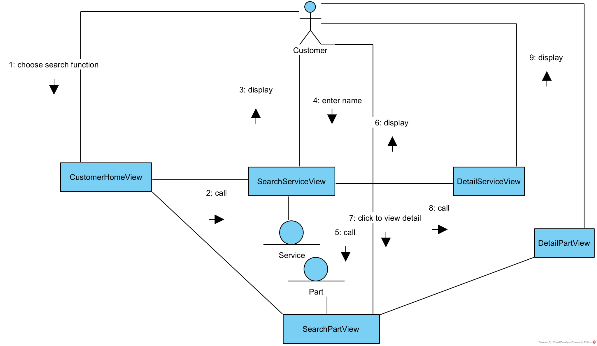

Sequence diagram
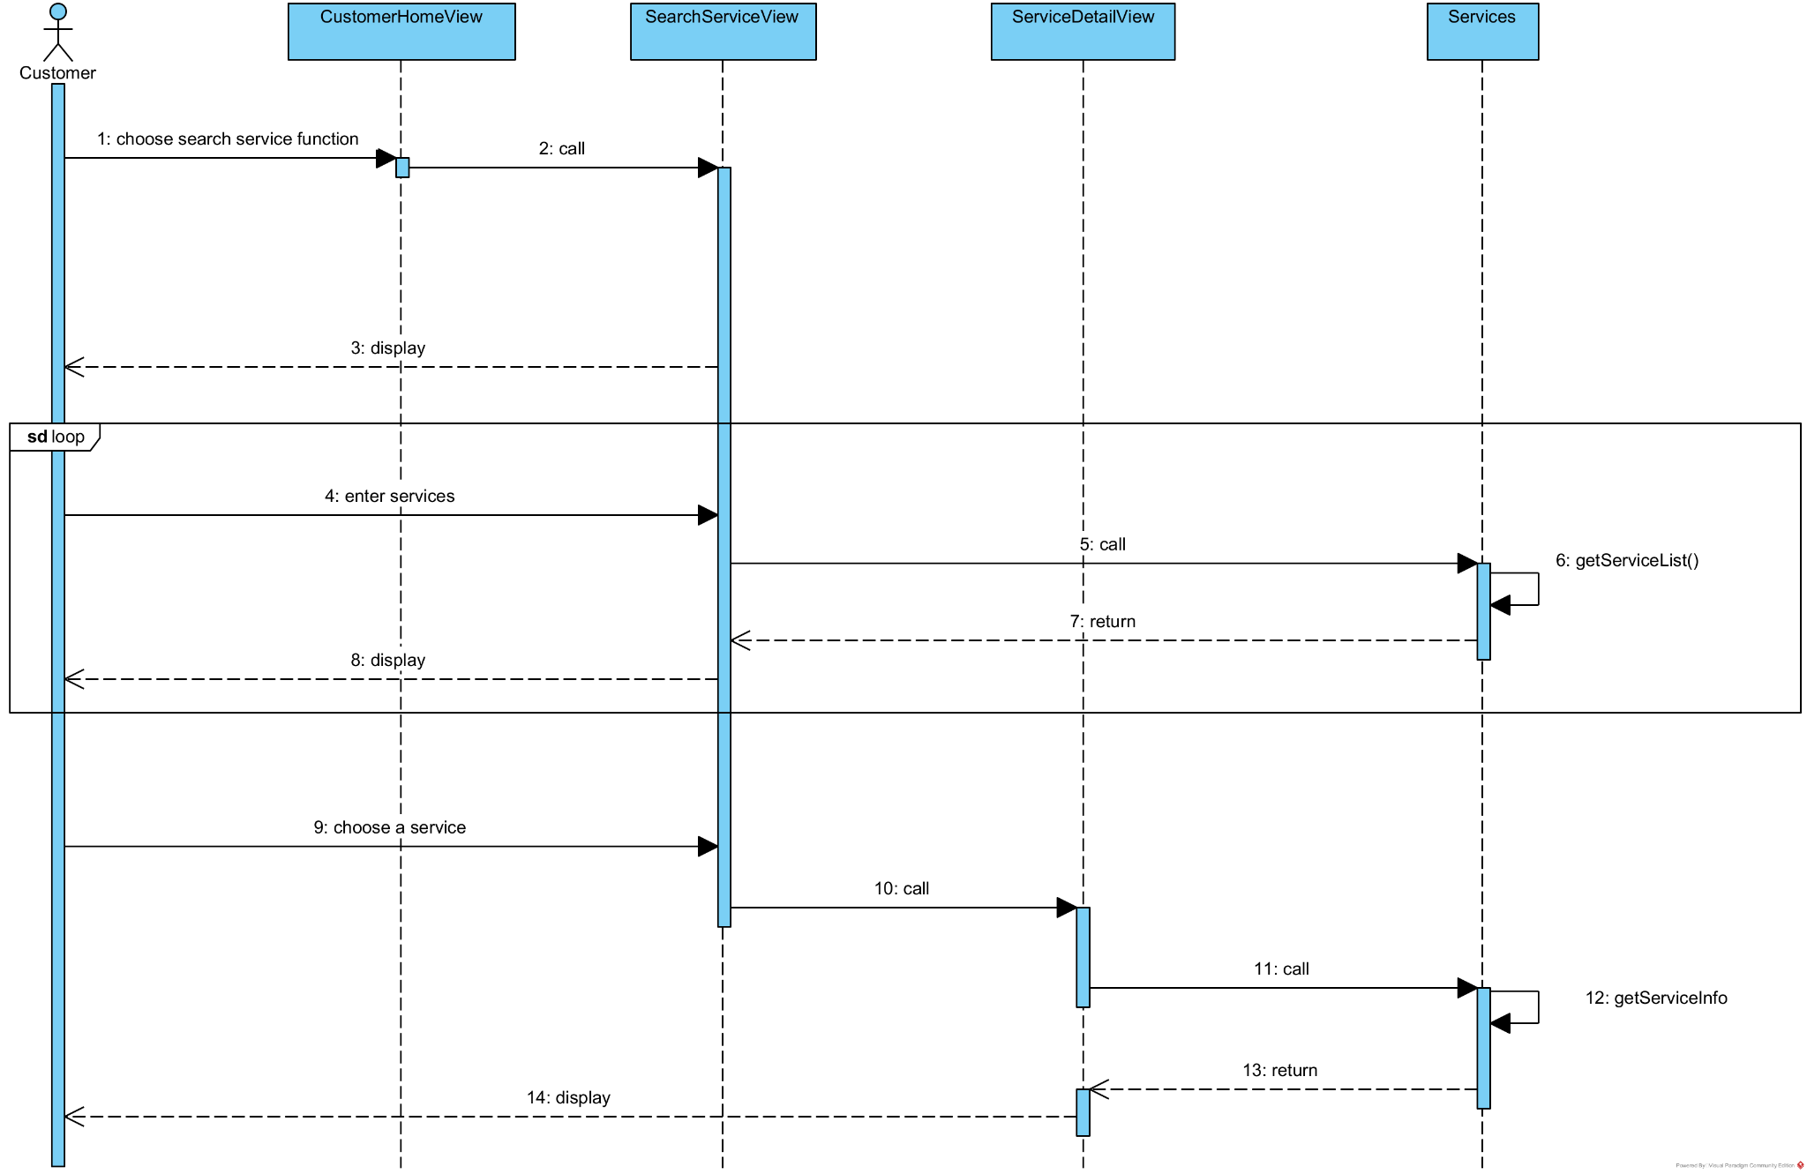

4.2 Module Warehouse Staff import parts
Activity diagram
1. On the warehouse staff’s main interface, the system will switch to the ImportHomeView when the Import Parts function is selected.

2. On the Import Parts interface, the system will switch to the SearchSupplierView if the staff chooses the Select Supplier function.
3. On the SearchSupplierView, when the staff selects a supplier, the system will switch to the SearchPartView.

4.On the SearchPartView, if the staff enters a part name and presses search, a list of parts whose names contain the entered keyword will be displayed.

5. On the ImportPartView, if the staff clicks to select part from the displayed list, the selected materials list will appear below.

6. On the ImportPartView, the system will switch to the ImportPartView if the staff enters quantities for the selected materials and presses OK.

7. On the ImportPartView, the system will switch to the Print Invoice interface if the staff chooses Confirm.

8. On the ConfirmView, after pressing Export Invoice, the system will save the invoice, the imported parts, and then finish the process.

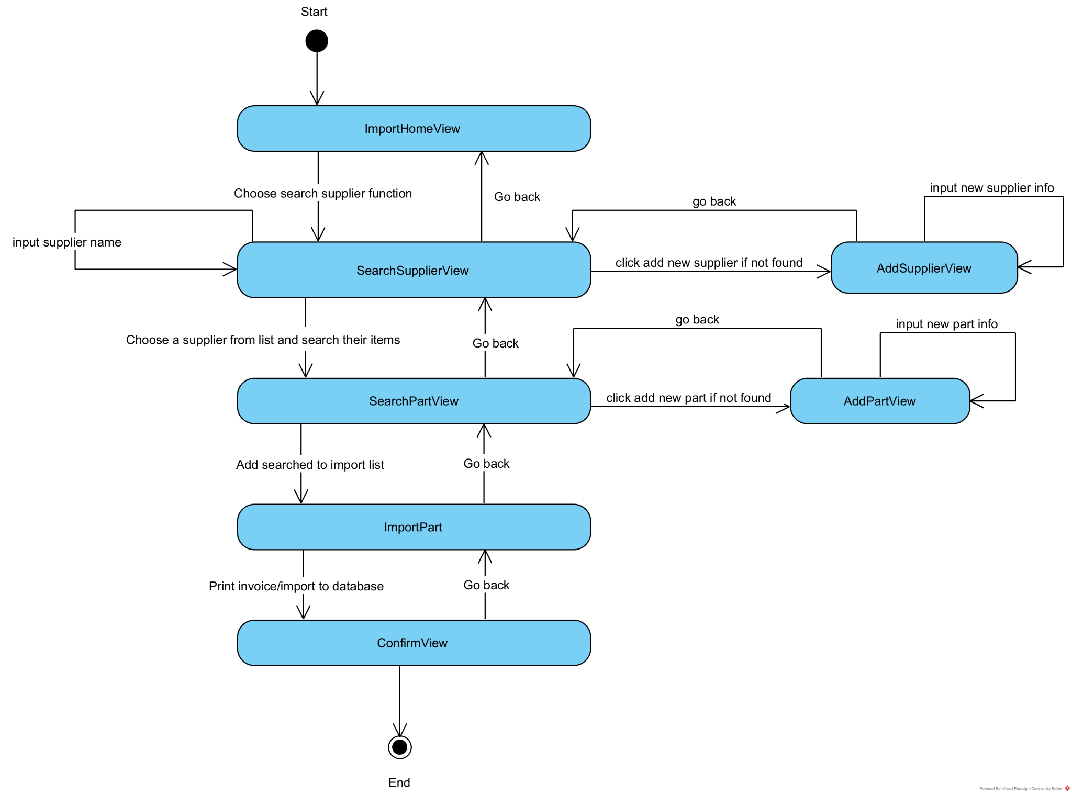
Scenario v.2:
1. On the ImportHomeView, the warehouse staff chooses the Search Supplier function.
2. The ImportHomeView calls SearchSupplierView .
3. The SearchSupplier is displayed to the staff.
4. The staff enter a supplier name to the search bar.
5. The SearchSupplier calls the class Supplier to request Supplier whose names contain the entered keyword.
6. Class Supplier searches for names that match the request.
7. Class Supplier returns results that match the request to SearchSupplierView.
8. The SearchSupplierView displays the result to the staff .
9. The staff select a supplier.
10.The SearchSupplierView calls SearchPartView.
11.The SearchPartView calls the class Part.
12.Class Parts use the method getPartList()
13. Class Parts return the result to SearchPartView
14.Class Parts display the staff all items of the searched supplier
15.The staff select items to import from the list and click import.
16. The SearchSupplierView calls the ImportPart.
17. The staff enter the quantity and unit price of those imported items .
18.The staff clicks confirm.
19.The ConfirmView saves data to the invoice.
20.The ConfirmView display the invoice to the supplier.

Communication diagram


Sequence diagram
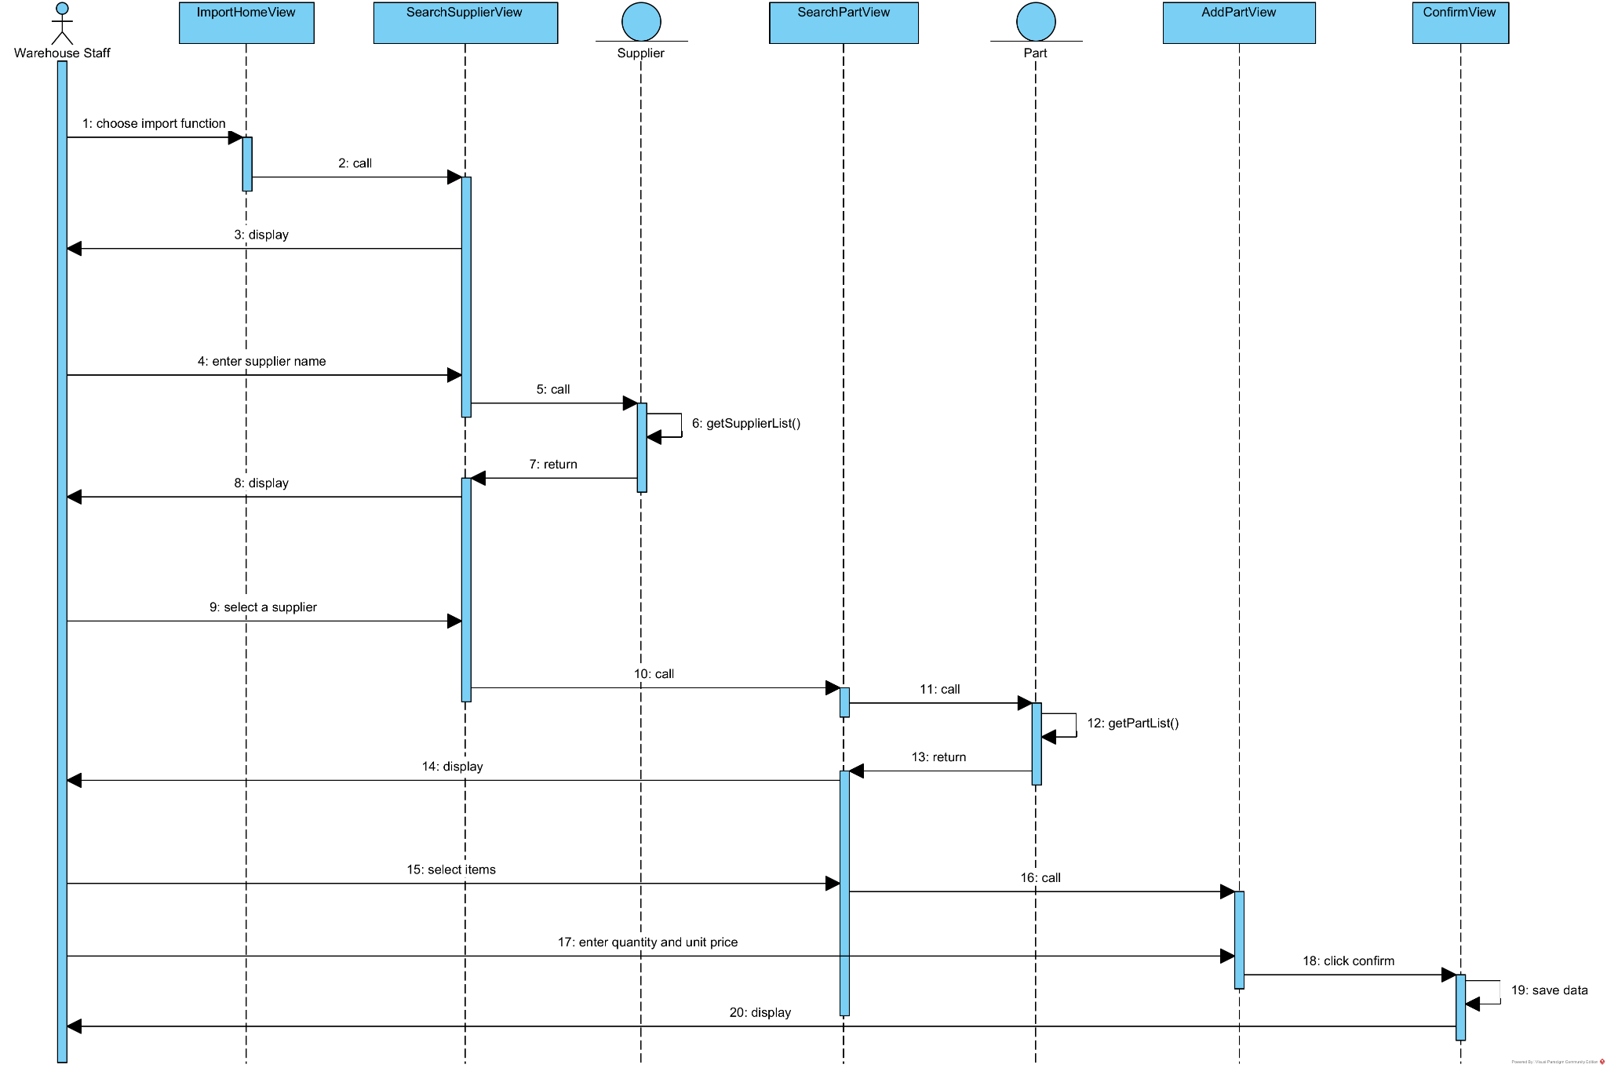

III. DESIGN
1. Entity Class Design
1.1. Module 1
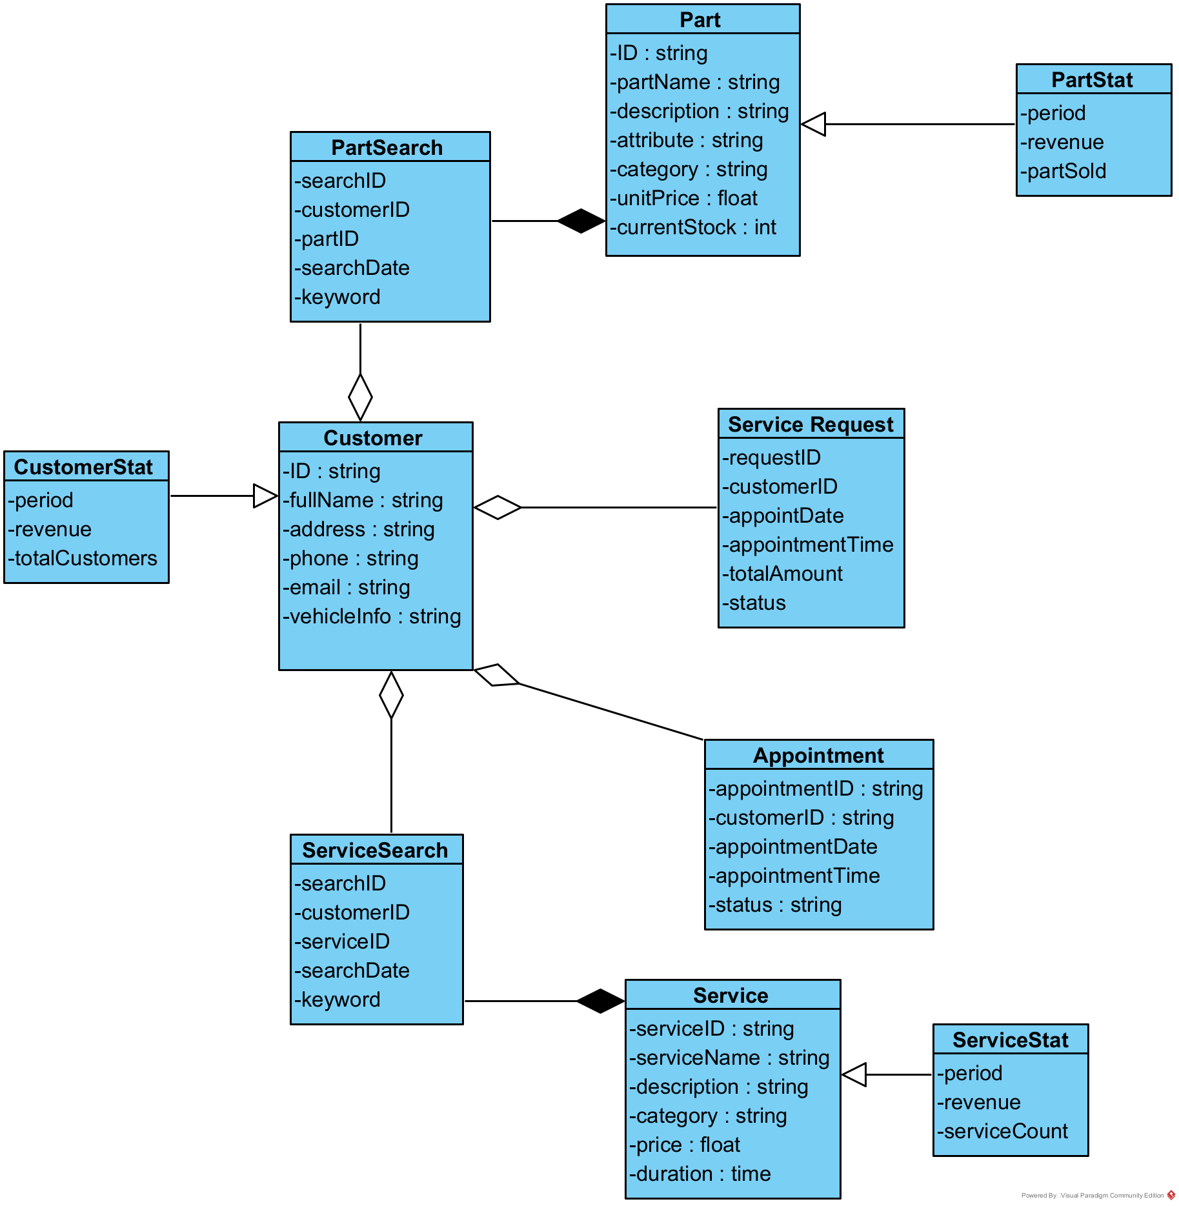
1.2 Module 2
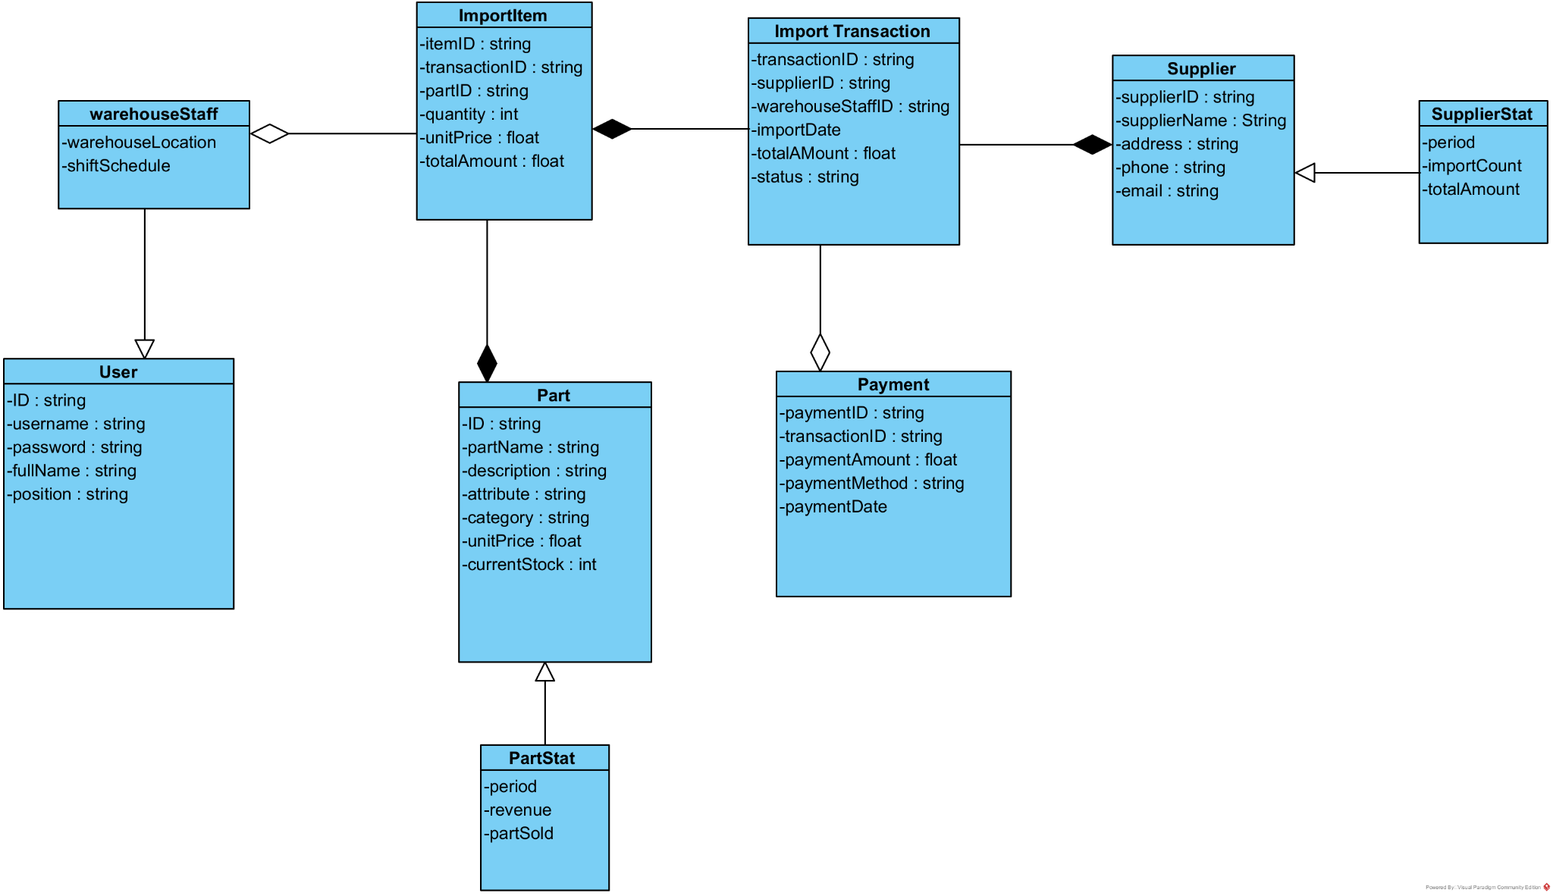

2. Database Design
2.1 Database module 1
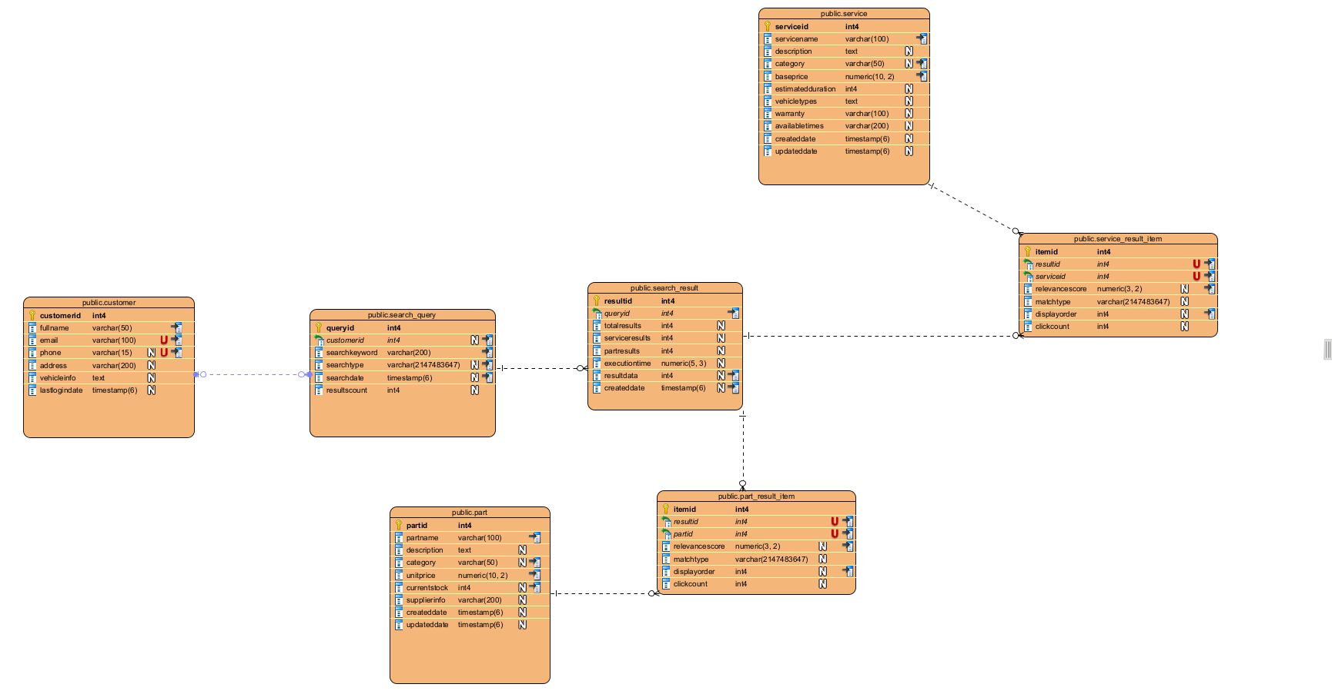
2.2 Database module 2
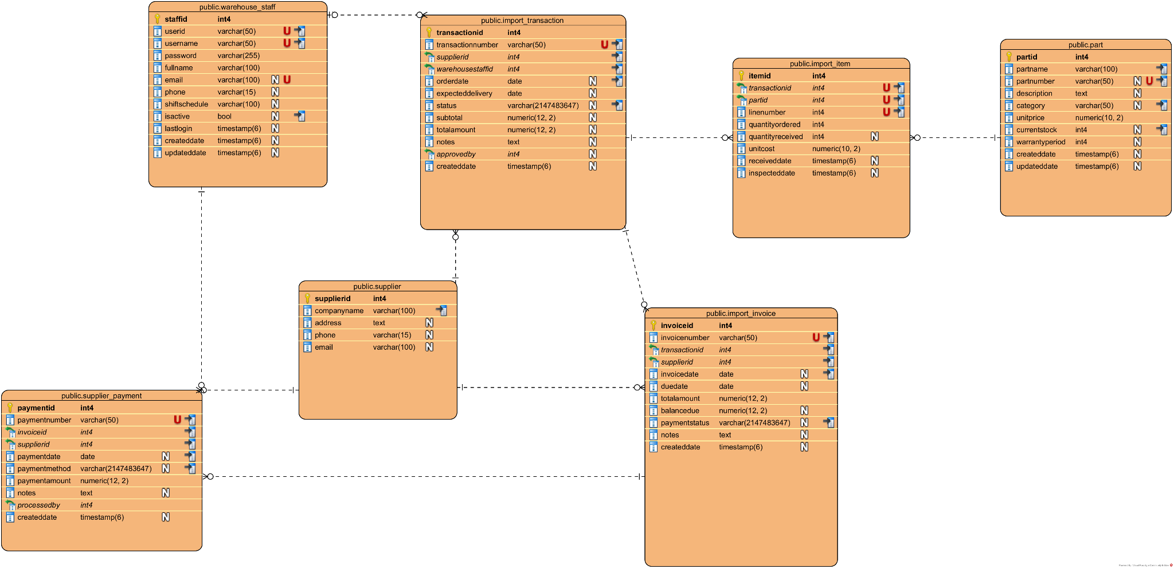
3. Class Diagram
3.1. Module 1

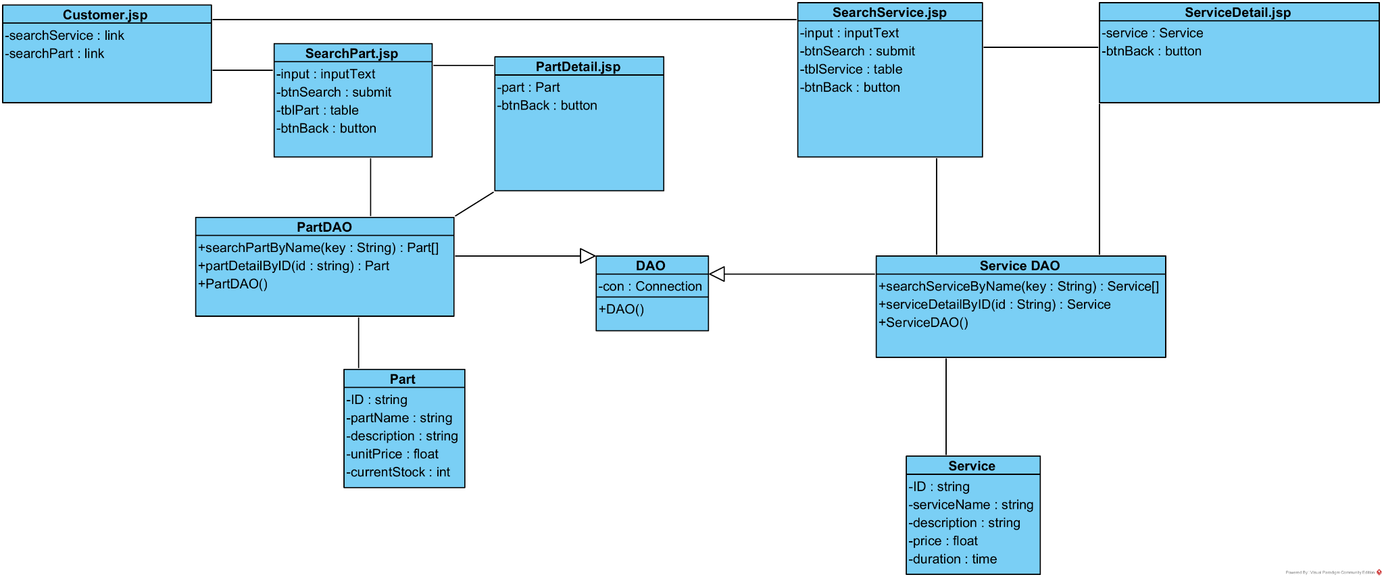
3.2.Module 2
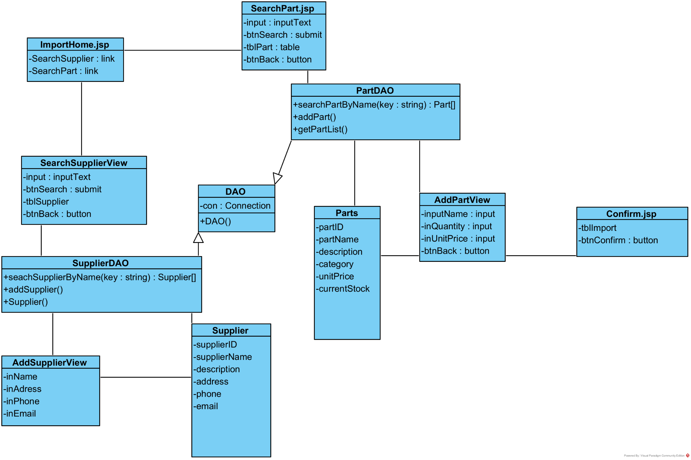
4. Activity Diagram

4.1 Module 1
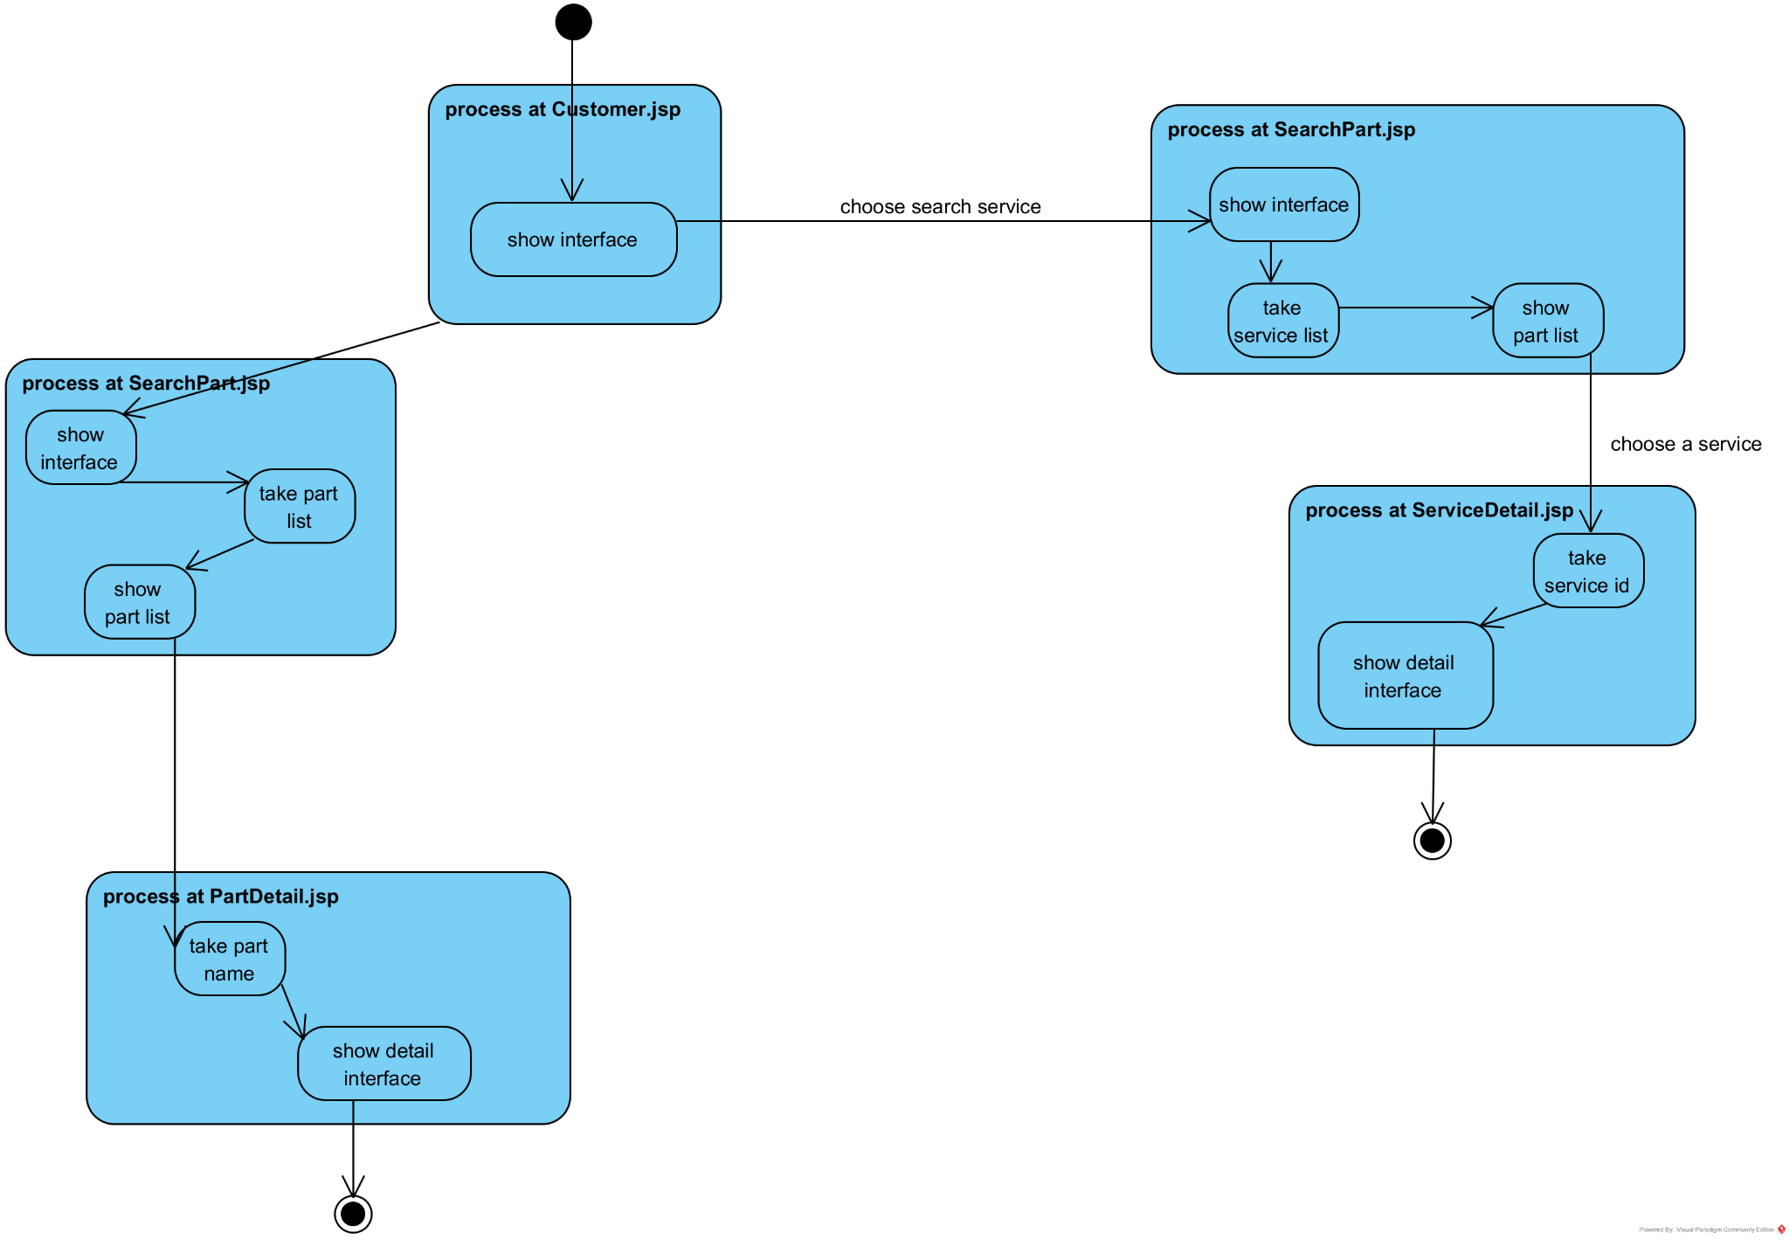
4.2.Module 2
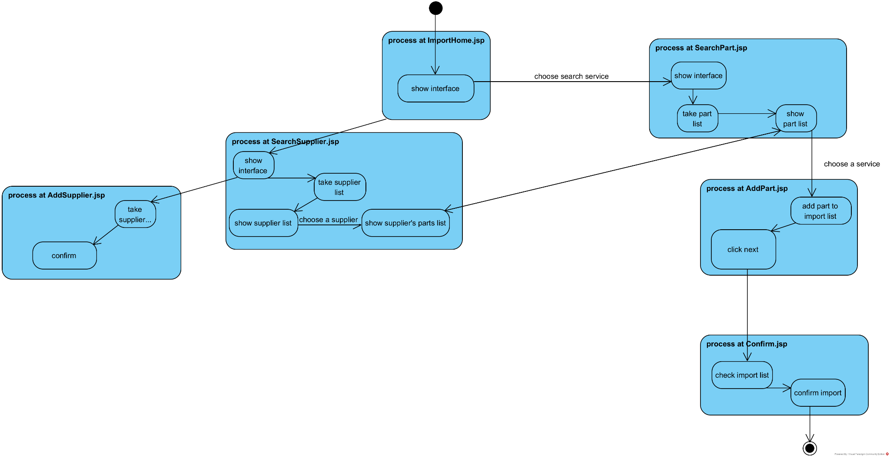

5. Scenario v3 + Sequence Diagram
5.1.1. Customer Search Service
1.At the main interface of the customer after logging in, the customer selects the service information search menu.
2.The CustomerInterface class calls the SearchService class.
3.The SearchService class displays to the customer.
4.The customer enters a keyword in the search box and clicks the search button.
5.SearchService calls the Service class requesting to retrieve the list of services whose names contain the entered keyword.
6.The Service class searches for the list of services.
7.The Service class returns the result to the SearchService class.
8.The SearchService class displays the service list to the customer.
9.The customer selects a service from the list.
10.The SearchService class calls the ServiceDetail class.
11.The ServiceDetail class calls the Service class to retrieve detailed information of the service with the selected id.
12.The Service class retrieves the detailed information of the service.
13.The Service class returns the result to the ServiceDetail class.
14.The ServiceDetail class displays the information to the customer.
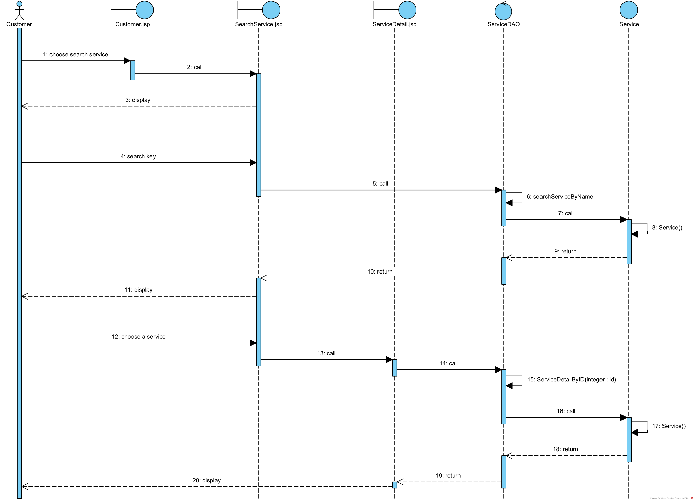

5.1.2. Customer Search Part
1.At the main interface of the customer after logging in, the customer selects the service information search menu.
2.The CustomerInterface class calls the SearchPart class.
3.The SearchPart class displays to the customer.
4.The customer enters a keyword in the search box and clicks the search button.
5.SearchPart calls the Part class requesting to retrieve the list of parts whose names contain the entered keyword.
6.The Part class searches for the list of parts.
7.The Part class returns the result to the SearchPart class.
8.The SearchPart class displays the Part list to the customer.
9.The customer selects a part from the list.
10.The SearchPart class calls the PartDetail class.
11.The PartDetail class calls the Part class to retrieve detailed information of the part with the selected id.
12.The Part class retrieves the detailed information of the part.
13.The Part class returns the result to the PartDetail class.
14.The PartDetail class displays the information to the customer.

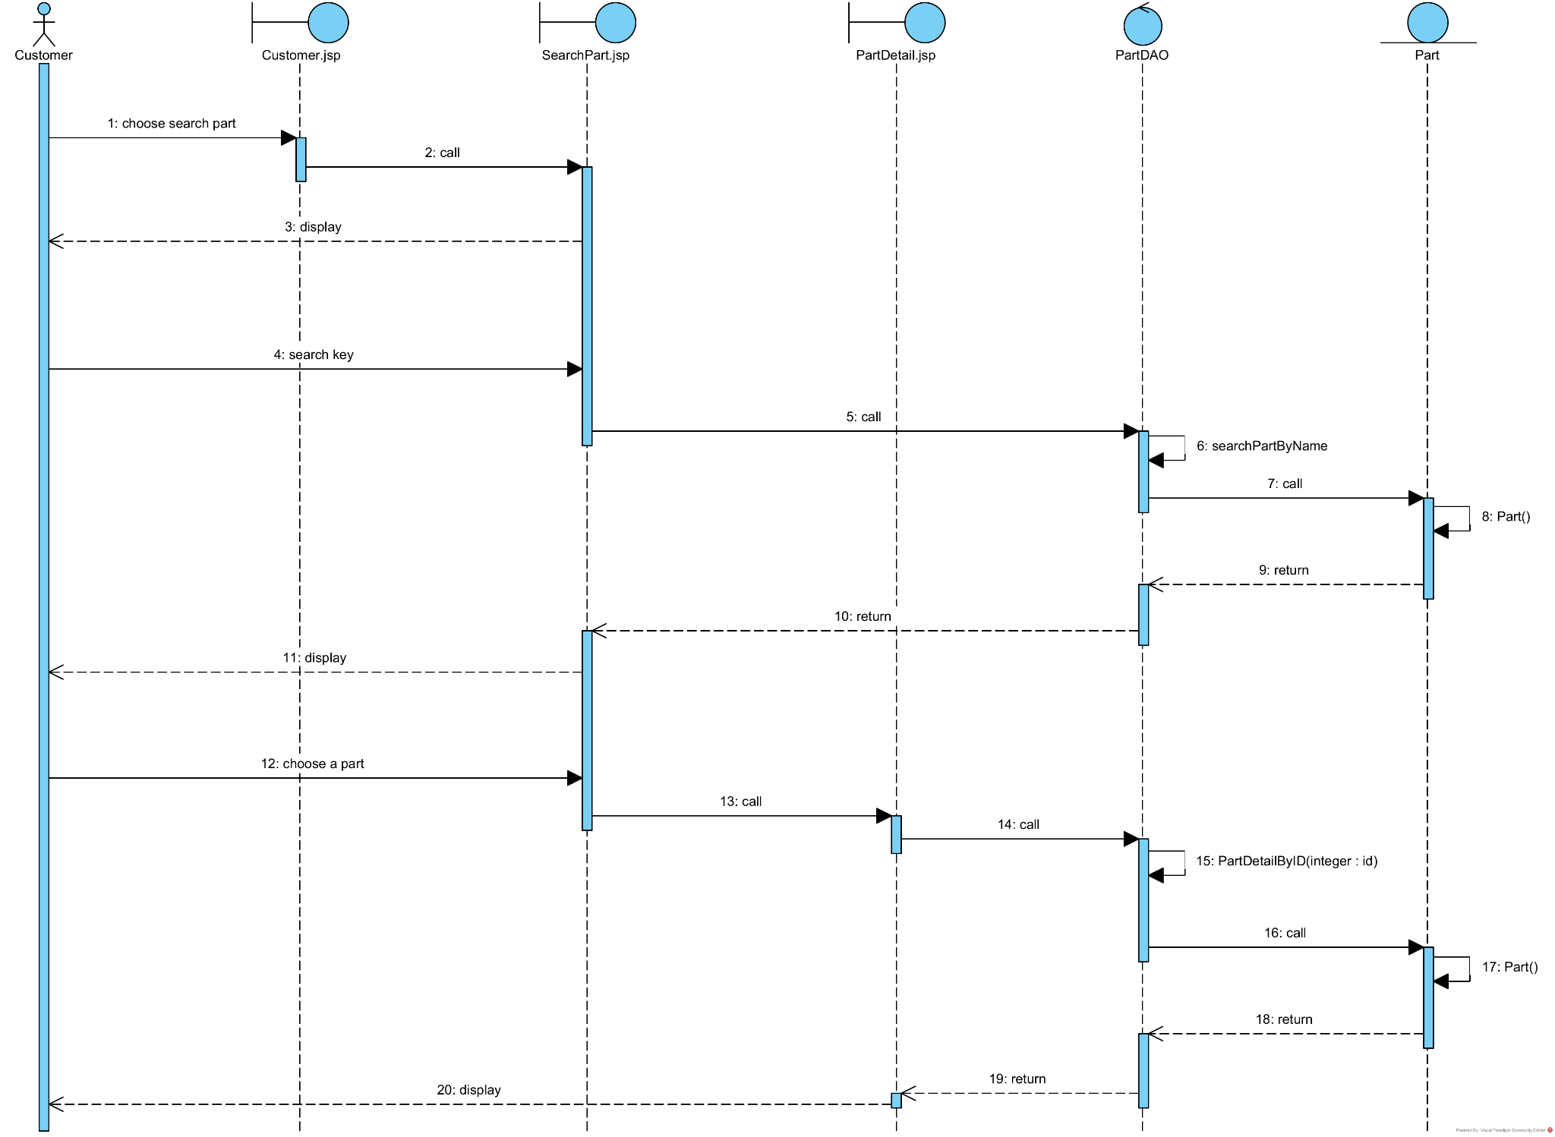
5.2. Warehouse staff import part
1. On the ImportHome.jsp page, after successfully logging in, warehouse staff selects "Search Supplier" link.
2. The ImportHome.jsp page calls the SearchSupplierView.jsp page.
3. The SearchSupplierView.jsp page displays to the warehouse staff.
4. The warehouse staff enters supplier name keyword in the search box and clicks the search button (btnSearch).
5. The SearchSupplierView.jsp page calls the SupplierDAO class with searchSupplierByName(String key) function.
6. The SupplierDAO class executes the searchSupplierByName()
7. Method searchSupplierByName() calls the Supplier class to encapsulate the results.
8. The Supplier class returns the supplier list to SearchSupplierView.jsp page.
9. The SearchSupplierView.jsp page displays the supplier list in tblSupplier table.
10. The warehouse staff selects a supplier from the list.
11. The system navigates to SearchPart.jsp page.
12. The SearchPart.jsp page displays with the selected supplier information.
13. The warehouse staff enters part name keyword in the search box (input) and clicks search button (btnSearch).
14. The SearchPart.jsp page calls the PartDAO class with searchPartByName(String key) function.
15. The PartDAO class executes the method searchPartByName()
16. Method searchPartByName() calls the Parts class to encapsulate the results.
17. The Parts class returns the parts list to SearchPart.jsp page.
18. The SearchPart.jsp page displays to warehouse staff the parts list in tblPart table.
19. The warehouse staff selects a part from the list.
20. The SearchPart.jsp call AddPart.jsp
21. The AddPart.jsp display to the staff
22. The warehouse staff enter quantity and unit price of that part
23. Repeat until done, the AddPart.jsp call Confirm.jsp
24. The warehouse staff click confirm and the method Confirm() is called
25. The method Confirm() display to the staff with a “Import successfully” message

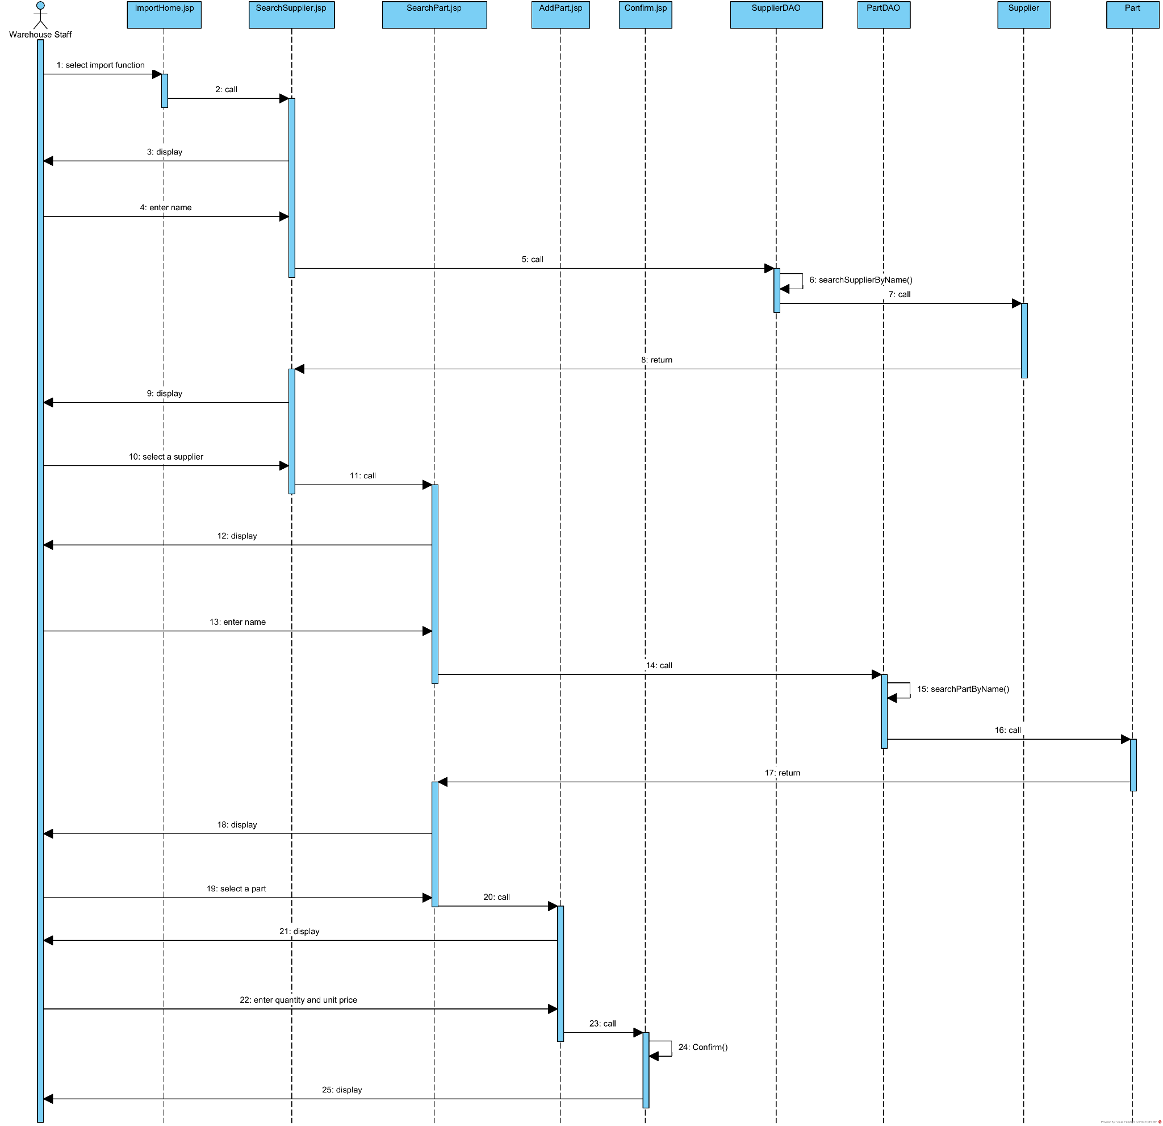

III. DESIGN
1. Entity Class Design
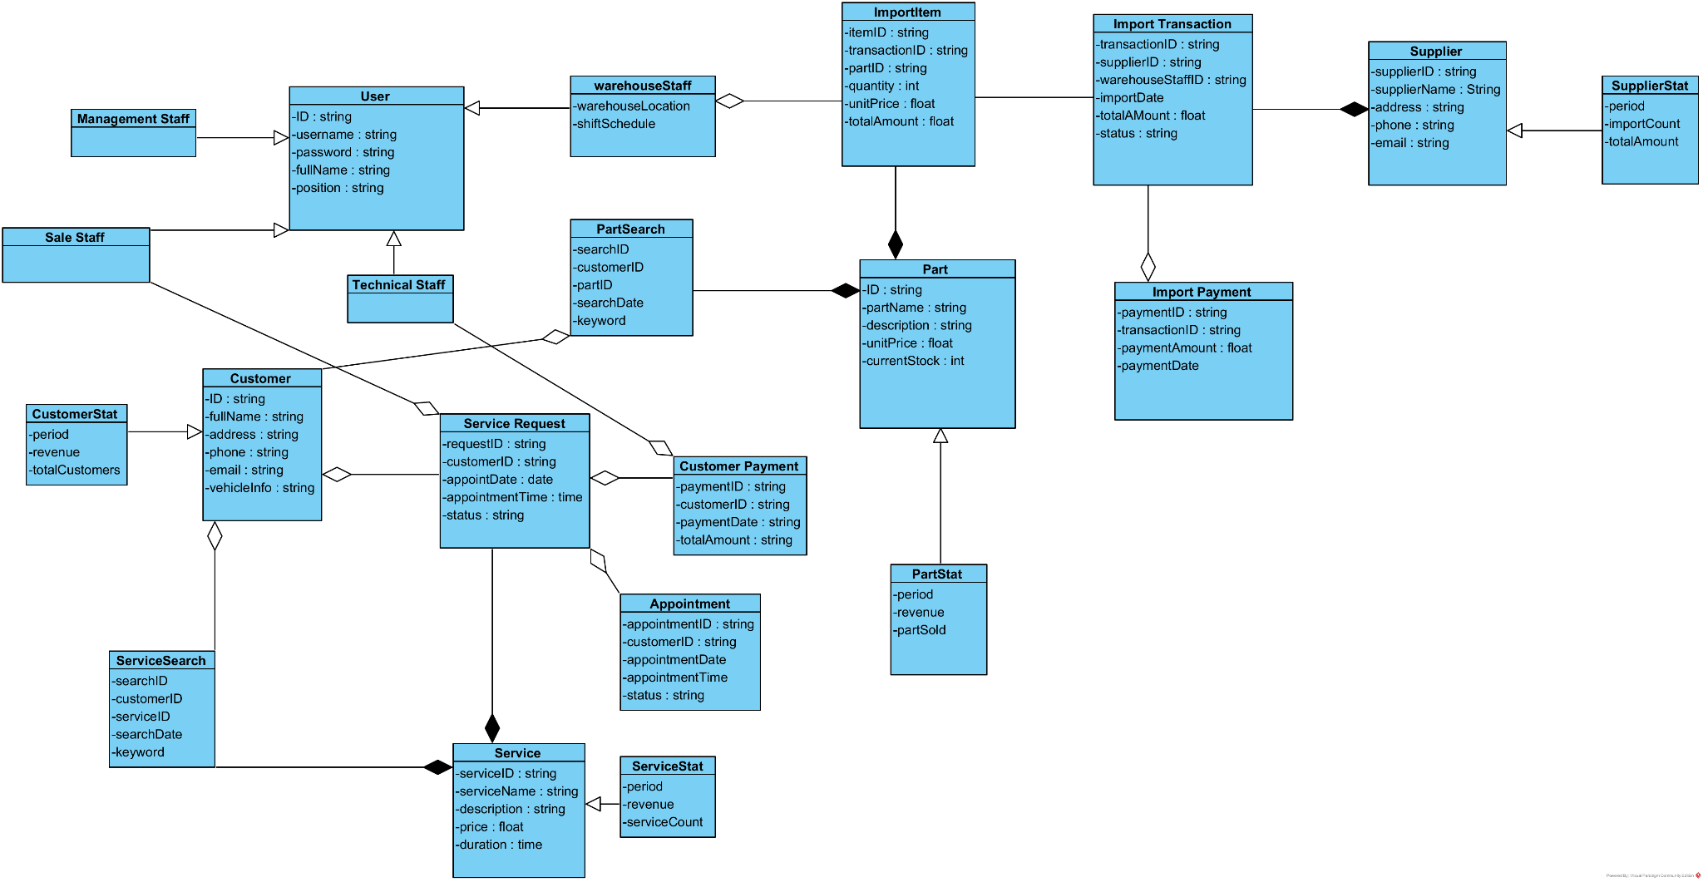

2. Database Design
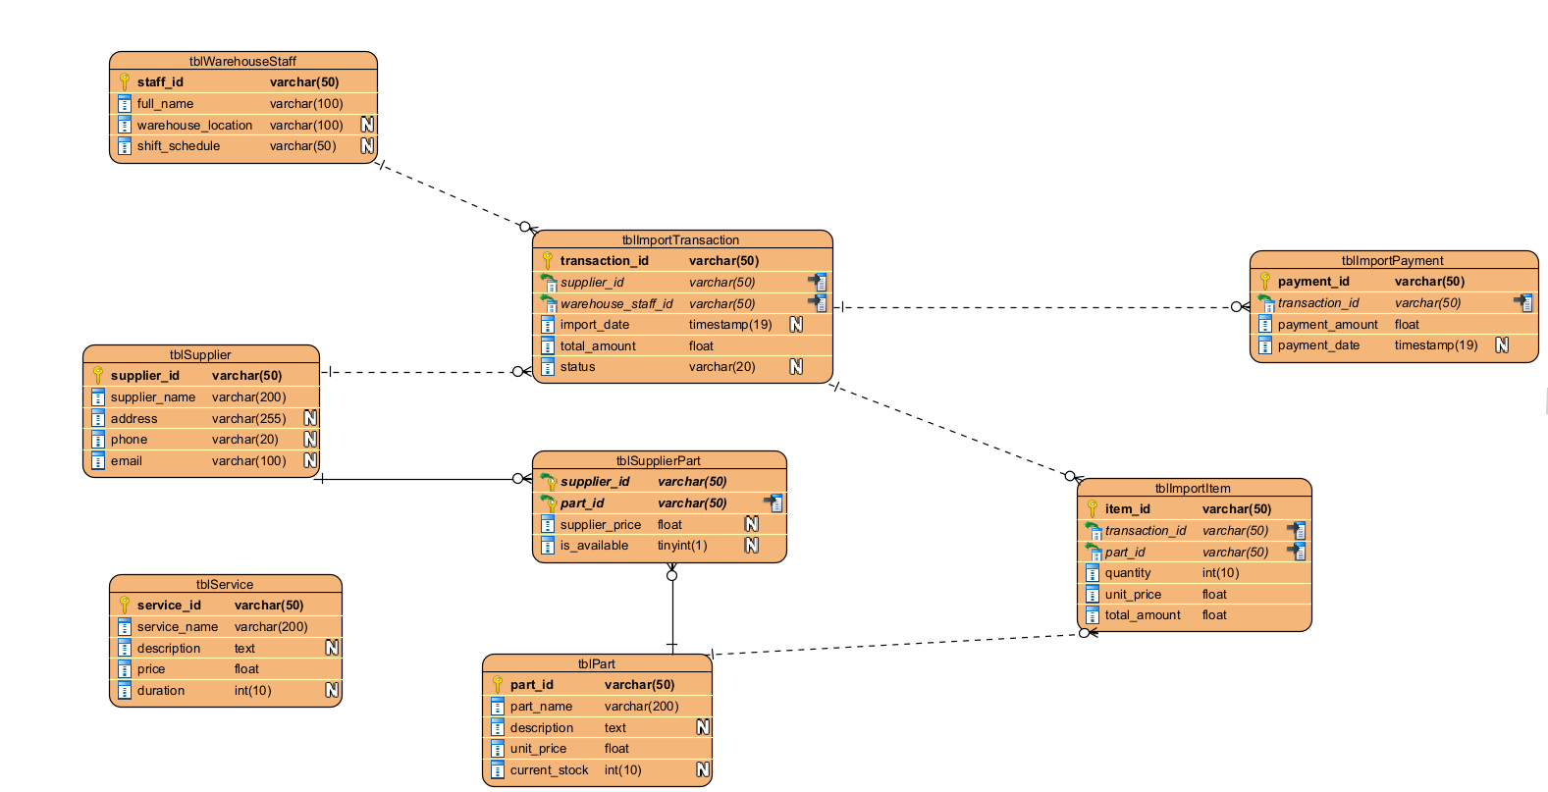

3. Class Diagram
3.1. Module Customer Search Service/Part
- The interfaces are JSP pages: CustomerView.jsp, SearchPartView.jsp, PartDetailView.jsp, SearchServiceView.jsp, ServiceDetail.jsp
- DataProcessing (Servlet) layer: PartServlet, ServiceServlet
- The data access layer (DAO) classes: PartDAO, ServiceDAO
- The related entity classes.

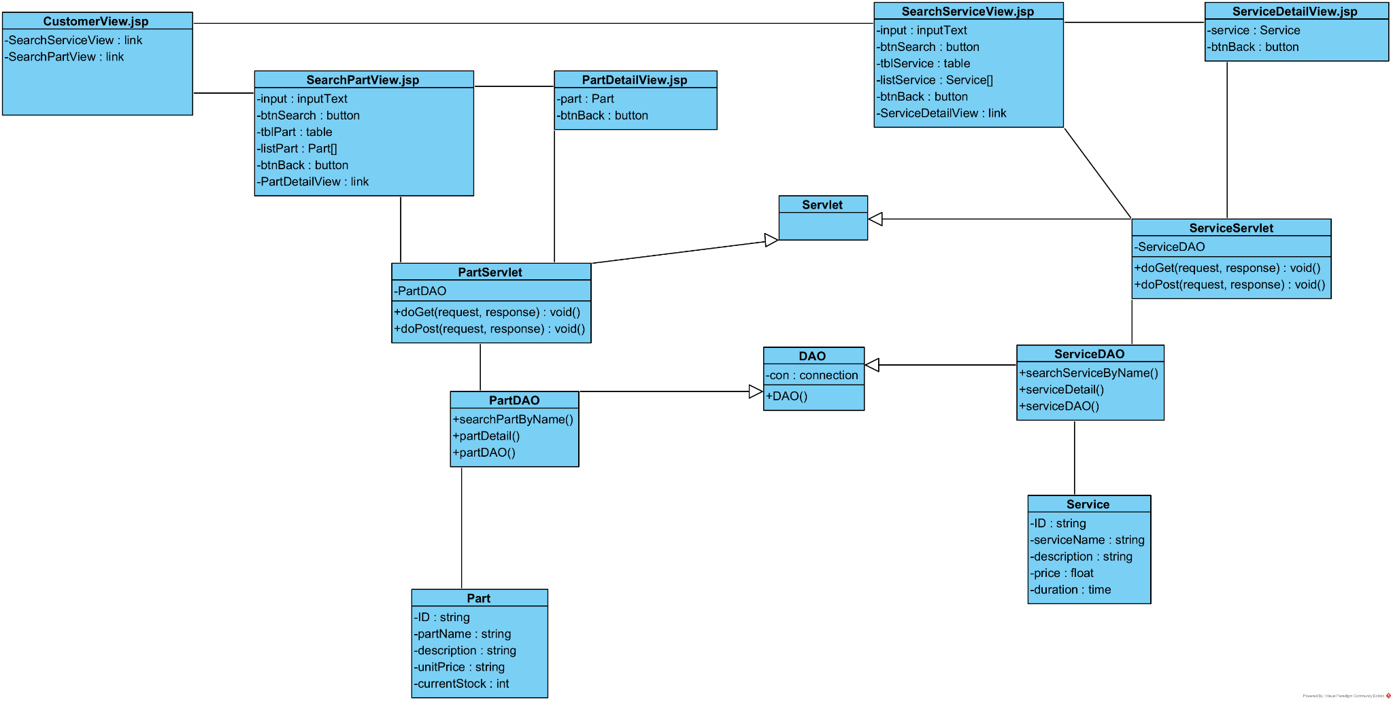
3.2.Module Warehouse Staff import parts
- The interfaces are JSP pages: ImportHomeView.jsp, SearchPartView.jsp, PartDetailView.jsp, SearchSupplierView.jsp, SupplierPart.jsp, ImportPartView.jsp, InvoiceView.jsp
- DataProcessing (Servlet) layer: PartServlet, SupplierServle, InvoiceServlet
- The data access layer (DAO) classes: PartDAO, SupplierDAO, InvoiceDAO
- The related entity classes.
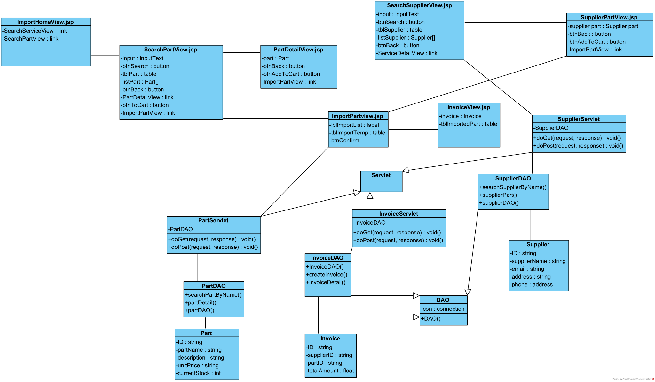
4. Activity Diagram

4.1 Module Customer Search Service

4.2.Module Customer Search Part


5. Scenario v3 + Sequence Diagram
5.1.1. Customer Search Service
1.At the main interface of the customer after logging in, the customer selects the service information search menu.
2.The CustomerInterface class calls the SearchServiceView class.
3.The SearchServiceView class displays to the customer.
4.The customer enters a keyword in the search box and clicks the search button.
5.SearchService use http request to call ServiceServlet class
6.The ServiceServlet class getParameter("keyword") and call to ServiceDAO
7.The ServiceDAO use method searchServiceByName().
8. The method calls model Service.
9.The model Service use method Service()
10. the method return to ServiceDAO().
11. The method return to ServiceServlet
12. The ServiceServlet return to SearchServiceView
13. The list on SearchServiceView is displayed to the customer
14. The Customer choose a Service from the list
15. SearchServiceView call ServiceDetailView
16.ServiceDetailView use http request method to call ServiceServlet
17. ServiceServlet call ServiceDAO
18. ServiceDAO use method ServiceDetail()
19. The method call to Service model
20. Service model use method Service()
21. Service model return result to ServiceDAO
22. ServiceDAO return result to ServiceServlet
23.ServiceServlet return to ServiceDetailView
24. ServiceDetailView displays the result to the customer

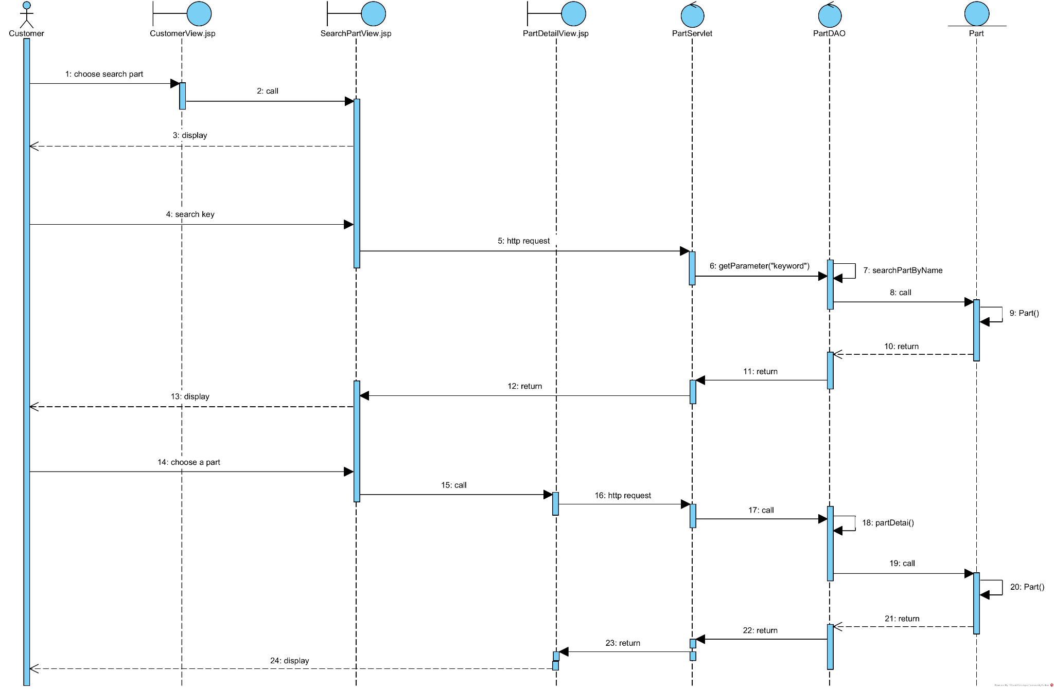

5.1.2. Customer Search Part
1.At the main interface of the customer after logging in, the customer selects the service information search menu.
2.The CustomerInterface class calls the SearchPartView class.
3.The SearchPartView class displays to the customer.
4.The customer enters a keyword in the search box and clicks the search button.
5.SearchPart use http request to call PartServlet class
6.The PartServlet class getParameter("keyword") and call to PartDAO
7.The PartDAO use method searchPartByName().
8. The method calls model Part.
9.The model Part use method Part()
10. the method return to PartDAO().
11. The method return to PartServlet
12. The PartServlet return to SearchPartView
13. The list on SearchPartView is displayed to the customer
14. The Customer choose a part from the list
15. SearchPartView call PartDetailView
16.PartDetailView use http request method to call PartServlet
17. PartServlet call PartDAO
18. PartDAO use method partDetail()
19. The method call to Part model
20. Part model use method Part()
21. Part model return result to PartDAO
22. PartDAO return result to PartServlet
23.PartServlet return to PartDetailView
24. PartDetailView displays the result to the customer


5.2. Warehouse staff import part
1. On the ImportHome.jsp page, after successfully logging in, warehouse staff selects "Search Supplier" link.
2. The ImportHome.jsp page calls the SearchSupplierView.jsp page.
3. The SearchSupplierView.jsp page displays to the warehouse staff.
4. The warehouse staff enters supplier name keyword in the search box and clicks the search button (btnSearch).
5. The SearchSupplierView.jsp page calls the SupplierDAO class with searchSupplierByName(String key) function.
6. The SupplierDAO class executes the searchSupplierByName()
7. Method searchSupplierByName() calls the Supplier class to encapsulate the results.
8. The Supplier class returns the supplier list to SearchSupplierView.jsp page.
9. The SearchSupplierView.jsp page displays the supplier list in tblSupplier table.
10. The warehouse staff selects a supplier from the list.
11. The system navigates to SearchPart.jsp page.
12. The SearchPart.jsp page displays with the selected supplier information.
13. The warehouse staff enters part name keyword in the search box (input) and clicks search button (btnSearch).
14. The SearchPart.jsp page calls the PartDAO class with searchPartByName(String key) function.
15. The PartDAO class executes the method searchPartByName()
16. Method searchPartByName() calls the Parts class to encapsulate the results.
17. The Parts class returns the parts list to SearchPart.jsp page.
18. The SearchPart.jsp page displays to warehouse staff the parts list in tblPart table.
19. The warehouse staff selects a part from the list.
20. The SearchPart.jsp call AddPart.jsp
21. The AddPart.jsp display to the staff
22. The warehouse staff enter quantity and unit price of that part
23. Repeat until done, the AddPart.jsp call Confirm.jsp
24. The warehouse staff click confirm and the method Confirm() is called
25. The method Confirm() display to the staff with a “Import successfully” message

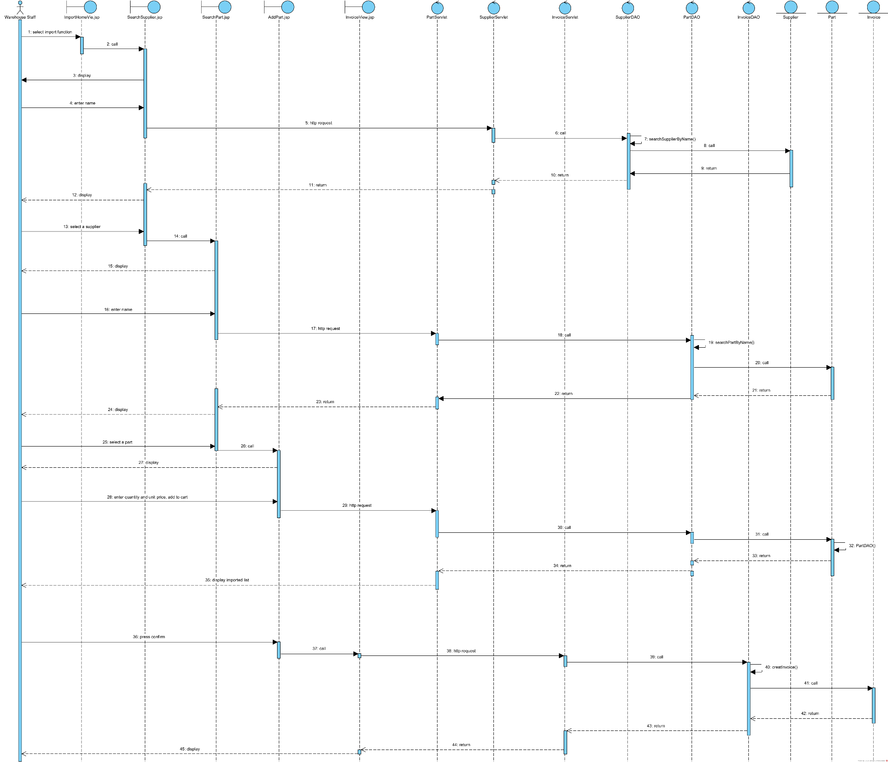

6. Package Diagram
Module Customer Search Service/Part
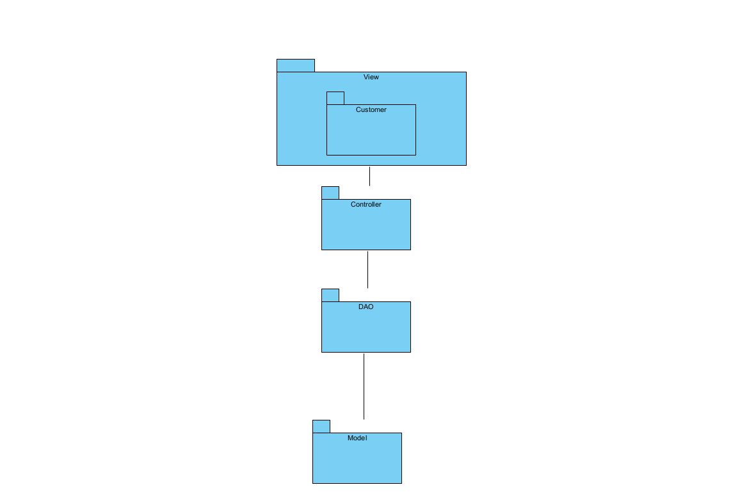

Module Warehouse Staff import parts
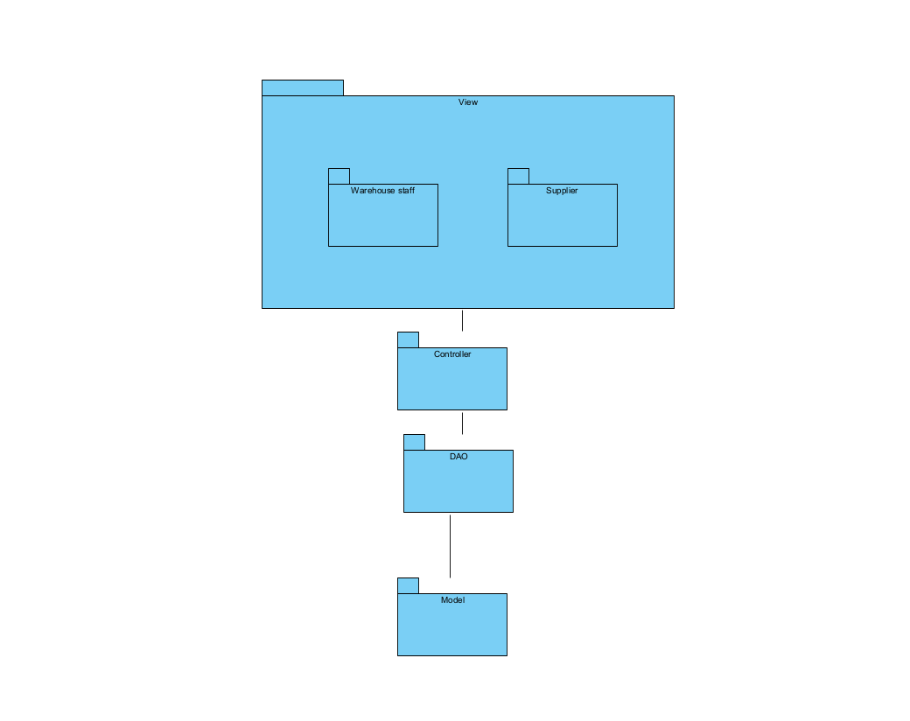

7. Deploy Diagram
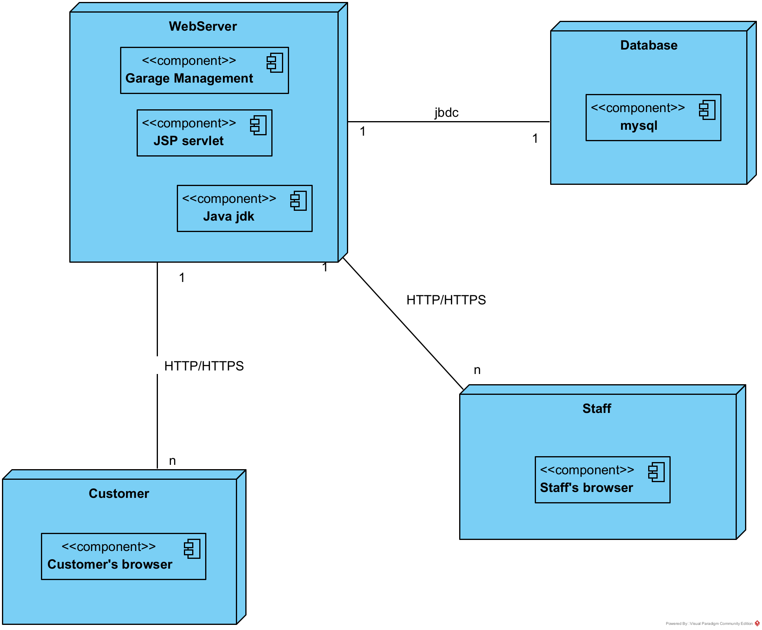

IV. Interface & Coding
- Interface
Main menu:
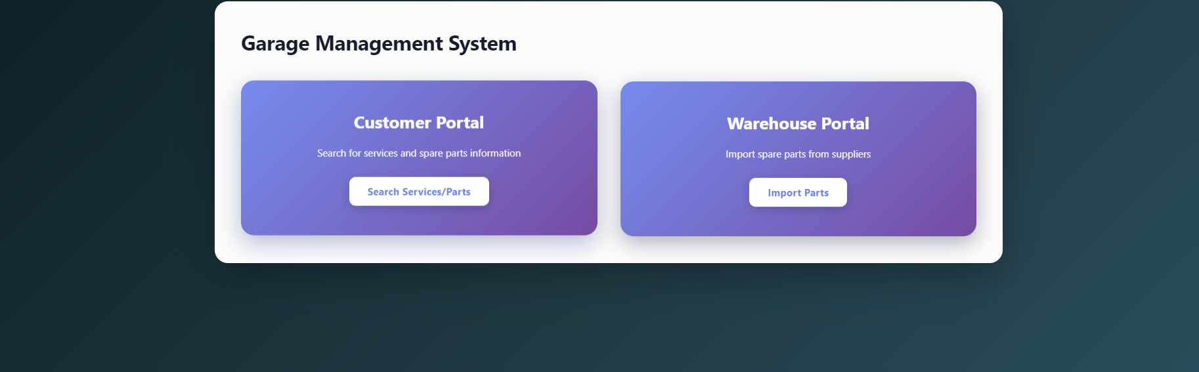
Module search:
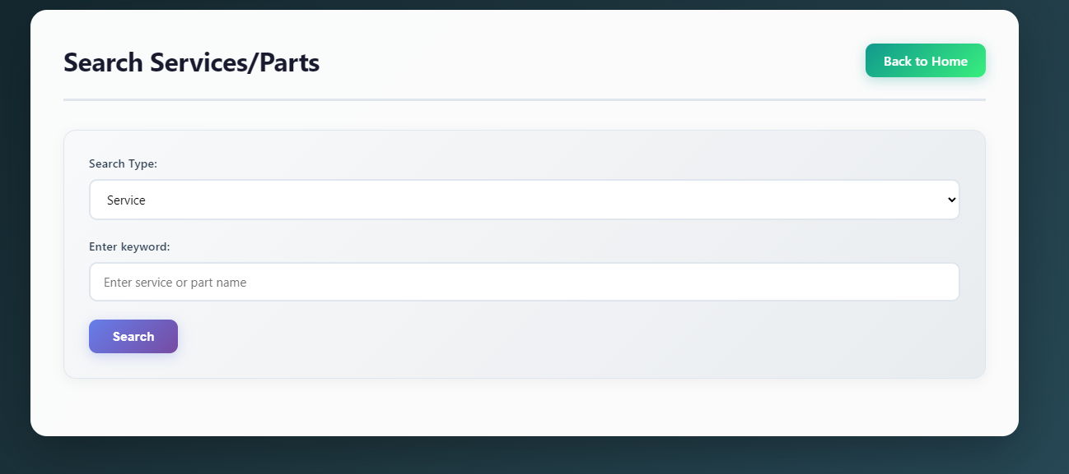

Module import:
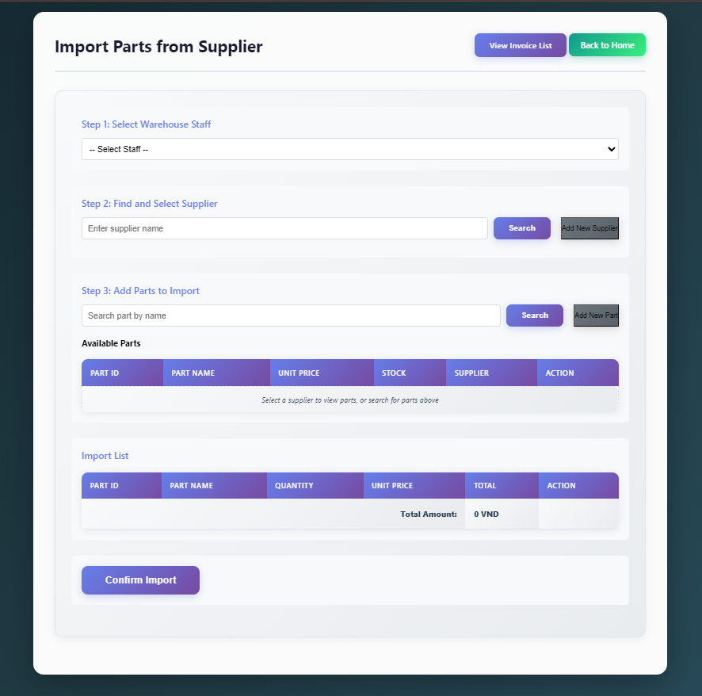

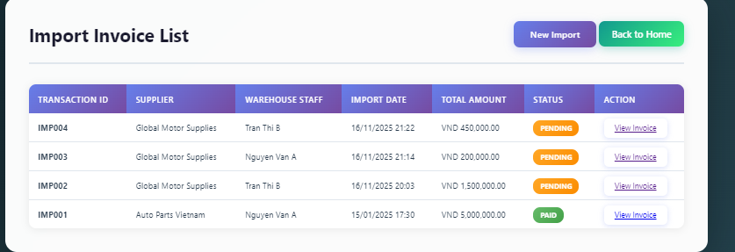
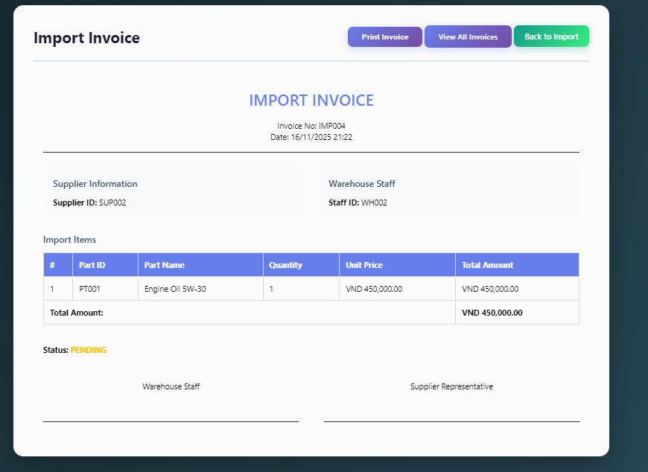
- Code structure
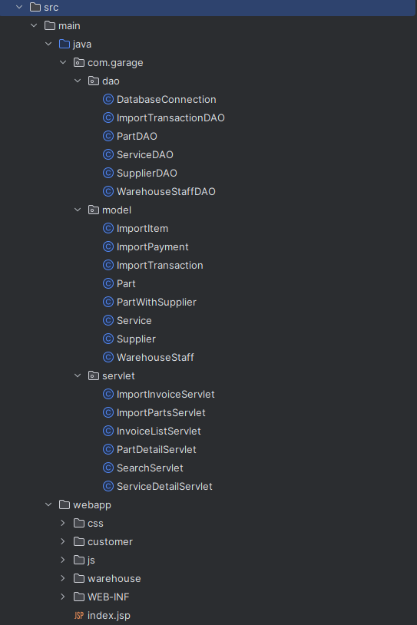
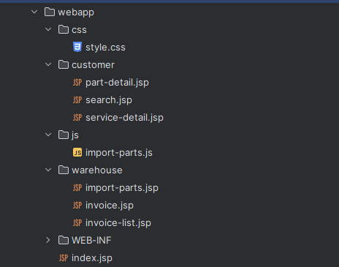
link source code: https://github.com/Hnim2910/garage_management

